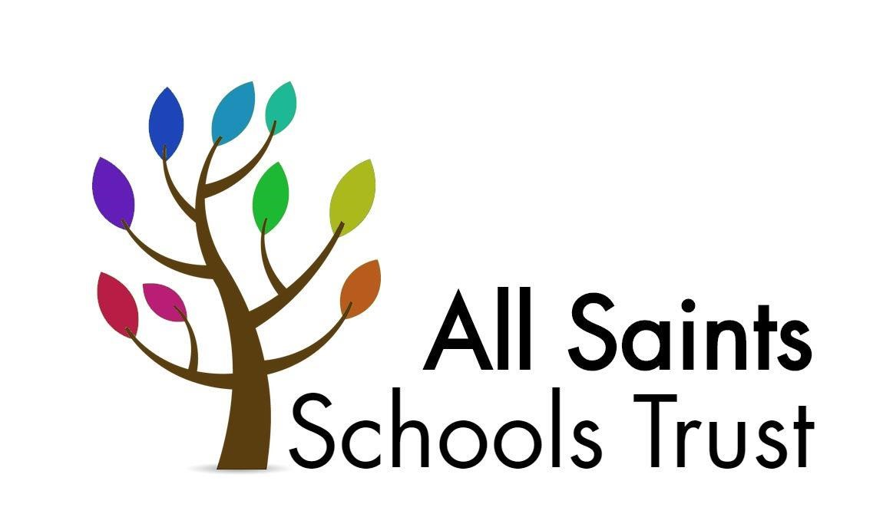
(
Child Protection and Safeguarding Policy 2025-2026

Including PREVENT/Channel (radicalisaton/ extremism) and Low Level Concerns Policy

Approved: September 2025
To be reviewed: September 2026

All Saints Schools Trust

Child Protection and Safeguarding Policy
2025-2026

Prepared by: | Melanie Barrow
Approved by: | All Saints Trust Board
Chair of Trust Board: | Russell Ayling
Status & review cycle | Statutory Annual
Date approved: | September 2025
Review date: | September 2026

Safeguarding Team Contacts

All Saints Laxfield
Role: | Name and contact details:
Designated Safeguarding Lead (DSL) | Katharine Minns Email:  k.minns@laxfieldprimary.org.uk  Daytime telephone Number: 01986 798344
Alternate DSL(s) | Daryl Jones  d.jones@asst.org.uk  01986 798344
Named safeguarding governor | Ben Hemmings Email:  b.hemmings@stradbrokeprimary.org.uk  01379 38441
Chair of Governors | Anna Fielding-O’Farrell  Email: a.fielding-  o'farrell@stradbrokeprimary.org.uk 01379 384415
School online safety Lead | Daryl Jones  d.jones@asst.org.uk  01986 798344
Designated teacher for Children in Care and children previously in care (CiC) | Katharine Minns Email:  k.minns@laxfieldprimary.org.uk  01986 798344

Benhall Primary
Role: | Name and contact details:
Designated Safeguarding Lead (DSL) | Daniel Millican  D.Millican@asst.org.uk  01728 602407
Alternate DSL(s) | Annie Flowers  01728 602407
Named safeguarding governor | Roland Edwards  roland.edwards@benhallschool.co.uk  01728 602407
Chair of Governors | Carolyn Glennon  carolyn.glennon@benhallschool.co.uk  01728 602407
School online safety Lead | Daniel Millican  D.Millican@asst.org.uk  01728 602407
Designated teacher for Children in Care and children previously in care (CiC) | Paul Parslow-Williams paul.williams@asst.org.uk  01728 602407

Charsfield Primary
Role: | Name and contact details:
Designated Safeguarding Lead (DSL) | Mark Taylor  m.taylor@asst.org.uk  01473 737347
Alternate DSL(s) | Amie Reeve  A.Reeve@charsfirldprimary.org.uk  01473 73734
Named safeguarding governor | Jill Wright  j.wright@asst.org.uk  01473 737347
Chair of Governors | Lucy Anstey  01473 737347
School online safety Lead | Mark Taylor  m.taylor@asst.org.uk  01473 737347
Designated teacher for Children in Care and children previously in care (CiC) | Mark Taylor  m.taylor@asst.org.uk  01473 737347

Cockfield Primary
Role: | Name and contact details:
Designated Safeguarding Lead (DSL) | Marc Gilbert  m.gilbert@asst.org.uk  01284 828287
Alternate DSL(s) | Lesley Tindall  L.Tindall@cockfieldprimary.org.uk  01284 828287
Named safeguarding governor | Rev. Sharon Potter  01284 828287
Chair of Governors | Rev. Sharon Potter  01284 828287
School online safety Lead | Marc Gilbert / Charlotte Leaman  C.Leaman@cockfieldprimary.org.uk  01284 828287
Designated teacher for Children in Care and children previously in care (CiC) | Marc Gilbert  M.Gilbert@asst.org.uk  01284 828287

Dennington Primary
Role: | Name and contact details:
Designated Safeguarding Lead (DSL) | Charys Rushbrook  c.rushbrook@denningtonprimary.org.uk  01728 638206
Alternate DSL(s) | Jenny Turner  j.turner@denningtonprimary.org.uk  01728 638206
Named safeguarding governor | Anne Lawrence  01728 638206
Chair of Governors | Kate Fell  01728 638206
School online safety Lead | Paul Parslow-Williams  paul.williams@asst.org.uk  01728 638206
Designated teacher for Children in Care and children previously in care (CiC) | Charys Rushbrook  c.rushbrook@denningtonprimary.org.uk  01728 638206

Fressingfield Primary
Role: | Name and contact details:
Designated Safeguarding Lead (DSL) | Mark Taylor  m.taylor@asst.org.uk  01473 737347
Alternate DSL(s) | Jeremy Leicester  J.Leicester@fressingfieldprimary.org.uk  01379 586393
Named safeguarding governor | Prue Rush  01379 586393
Chair of Governors | Judith Mobbs  01379 586393
School online safety Lead | Mark Taylor  m.taylor@asst.org.uk  01473 737347
Designated teacher for Children in Care and children previously in care (CiC) | Mark Taylor  m.taylor@asst.org.uk  01473 737347

Great Whelnetham Primary
Role: | Name and contact details:
Designated Safeguarding Lead (DSL) | Marc Gilbert  m.gilbert@asst.org.uk  01284 386203
Alternate DSL(s) | Nicky Tyler  n.tyler@greatwhelnethamprimary.org.uk  01284386203
Named safeguarding governor | Martina Groves  01284 386203
Chair of Governors | Sam Keast  01284386203
School online safety Lead | Marc Gilbert / Sam Sharp  s.sharp@greatwhelnethamprimary.org.uk  01284 386203
Designated teacher for Children in Care and children previously in care (CiC) | Marc Gilbert  m.gilbert@asst.org.uk  0128438620

Hardwick Primary
Role: | Name and contact details:
Designated Safeguarding Lead (DSL) | Hayley Clarke  01284 755424
Alternate DSL(s) | Claire Flatman  c.flatman@asst.org.uk  01284755424
Denise Dulieu
d.dulieu@hardwickprimary.org.uk
01284755424
Named safeguarding governor | Andy Abbott  01284 755424
Chair of Governors | Robert Heavisides  01284 755424
School online safety Lead | Hayley Clarke  01284 755424
Designated teacher for Children in Care and children previously in care (CiC) | Hayley Clarke  01284 755424

Ickworth Park Primary
Role: | Name and contact details:
Designated Safeguarding Lead (DSL) | Kirsten Steele (HT)  k.steele@asst.org.uk  01284 735337
Alternate DSL(s) | Elly Reynolds (DHT & SENDCo) e.reynolds@ickworthparkprimary.org.uk  Sarah Allen  s.allen@ickworthparkprimary.org.uk  01284 735337
Named safeguarding governor | Pippa Hilton  p.hilton@ickworthparkprimary.org.uk  01284 735337
Chair of Governors | Tom Lockwood  gov-t.lockwood@ickworthpark.co.uk  01284 735337
School online safety Lead | Kirsten Steele  k.steele@asst.org.uk  Nicki Asker  n.asker@ickworthparkprimary.org.uk  01284 735337
Designated teacher for Children in Care and children previously in care (CiC) | Sarah Allen  s.allen@ickworthparkprimary.org.uk  01284 735337

Occold Primary
Role: | Name and contact details:
Designated Safeguarding Lead (DSL) | Katie Thornton  K.Thornton@occoldprimary.org.uk  01379 678330
Alternate DSL(s) | Karen Squirrell  K.Squirrell@occoldprimary.org.uk  01379 678330
Named safeguarding governor | Carol Peters  01379 678330
Chair of Governors | Carol Peters  01379 678330
School online safety Lead | Gemma Watts  g.watts@asst.org.uk  01379 678330
Designated teacher for Children in Care and children previously in care (CiC) | Gemma Watts  g.watts@asst.org.uk  01379 678330

Sexton’s Manor Primary
Role: | Name and contact details:
Designated Safeguarding Lead (DSL) | James Murray  j.murray@sextonsprimary.org.uk  01284 754371
Alternate DSL(s) | Kirsten Steele  01473 737347  James Murray  j.murray@sextonsprimary.org.uk  Danielle Ballam  d.ballam@sextonsprimary.org.uk
Named safeguarding governor | Mr Richard Selby  r.selby@sextonsprimary.org.uk
Chair of Governors | Mr Richard Selby  r.selby@sexonsprimary.org.uk
School online safety Lead | James Murray  j.murray@sextonsprimary.org.uk  01284 754371
Designated teacher for Children in Care and children previously in care (CiC) | Danielle Ballam  d.ballam@sextonsprimary.org.uk  01473 737347

St Peter and St Paul, Eye Primary
Role: | Name and contact details:
Designated Safeguarding Lead (DSL) | Gemma Watts  g.watts@asst.org.uk  01379 831500
Alternate DSL(s) | Caroline Jarvis  c.jarvis@eyeprimary.org.uk  01379 831500
Named safeguarding governor | Theresa McNally tessa.mcnally@suffolk.gov.uk  01379 831500
Chair of Governors | Odile Wladon  o.wladon@asst.org.uk  01379 831500
School online safety Lead | Sophie Brown  s.brown@eyeprimary.org.uk  01379 831500
Designated teacher for Children in Care and children previously in care (CiC) | Gemma Watts  g.watts@asst.org.uk  01379 831500

Stradbroke Primary
Role: | Name and contact details:
Designated Safeguarding Lead (DSL) | Samantha Barlow  01379 384415
Alternate DSL(s) | Hannah Cragoe  h.cragoe@stradbrokeprimary.org.uk  01379 384415  Rebecca Keeble  r.keeble@stradbrokeprimary.org.uk  01379 384415  Daryl Jones  d.jones@asst.org.uk  01379 384415
Named safeguarding governor | Ben Hemmings  b.hemmings@stradbrokeprimary.org.uk  01379 384415
Chair of Governors | Anna Fielding-O’Farrell  a.fielding-o'farrell@stradbrokeprimary.org.uk  01379 384415
School online safety Lead | Daryl Jones  d.jones@asst.org.uk  01379 384415
Designated teacher for Children in Care and children previously in care (CiC) | Hannah Hunt  01379 384415  h.hunt@stradbrokeprimary.org.uk

Thorndon Primary
Role: | Name and contact details:
Designated Safeguarding Lead (DSL) | Hannah Meadowcroft  h.meadowcroft@thorndonprimary.org.uk  01379 678392
Alternate DSL(s) | Lorraine Bell-Tye  L.bell-tye@thorndonprimary.org.uk  01379 678392  Daryl Jones  d.jones@asst.org.uk  01379 678392
Named safeguarding governor | Rebecca Gooderham r.gooderham@thorndonprimary.org.uk  01379 678392
Chair of Governors | Stephen Page  s.page@thorndonprimary.org.uk  01379 678392
School online safety Lead | Daryl Jones  d.jones@asst.org.uk  01379 678392
Designated teacher for Children in Care and children previously in care (CiC) | Hannah Meadowcroft  h.meadowcroft@thorndonprimary.org.uk  01379 678392

Wortham Primary
Role: | Name and contact details:
Designated Safeguarding Lead (DSL) | Claire Flatman  c.flatman@asst.org.uk  01379 898484
Alternate DSL(s) | Michelle Erith  01379898484
Named safeguarding governor | Jo Thuell  01379 89848
Chair of Governors | Simon Furlong 01379 89848
School online safety Lead | Rececca Banham  01379 898484
Designated teacher for Children in Care and children previously in care (CiC) | Claire Flatman  c.flatman@asst.org.uk  01379 89848

Table of Contents

- Ethos statement

- Introduction

- Statutory framework

- Key roles and responsibilities

- Induction & Training

- Recognising concerns – signs and indicators of abuse

- Specific safeguarding issues

- Children potentially at greater risk of harm

- Opportunities to teach Safeguarding

- Online safety and filtering & monitoring

- Procedures

- Information sharing, record keeping and confidentiality

- Safeguarding concerns or allegations made about teachers, including supply teachers, other staff, volunteers and contractors.

- Use of school premises for non-school activities

- Whistleblowing

- Useful contacts and links

Appendix

- Appendix A – Further information on specific safeguarding issues

- Appendix B- MyConcern User Guide- guidance for raising concerns on school’s safeguarding management system further information on specific safeguarding issues

- Appendix C – Body map

- Appendix D- Preventing Radicalisation and Extremism

- Appendix E- Low Level Concerns Policy

School Child Protection and Safeguarding Policy Framework
Safeguarding and promoting the welfare of children is everyone’s responsibility. ‘Children’ includes everyone under the age of 18. Everyone who comes into contact with children and their families has a role to play. In order to fulfil this responsibility effectively, all practitioners should make sure their approach is child centred. This means that they should consider, at all times, what is in the best interest of the child.
(Keeping Children Safe in Education)

Ethos statement
We recognise the moral and statutory responsibility placed on all staff to safeguard and promote the welfare of all children. We aim to provide a safe and welcoming environment in which children can learn, underpinned by a culture of openness where both children and adults feel secure, are able to raise concerns and believe they are being listened to, and that appropriate action will be taken to keep them safe.

Introduction
ASST recognises the need to ensure that it complies with its duties under legislation and this policy has regard to statutory guidance, Keeping Children Safe in Education (KCSiE) 2025, Working Together to Safeguard Children 2023 and locally agreed inter-agency procedures put in place by Suffolk Safeguarding Partnership.

This policy will be reviewed annually, as a minimum, and will be made available publicly via the Trust website or on request.

Safeguarding and promoting the welfare of children is defined as: providing help and support to meet the needs of children as soon as problems emerge, protecting children from maltreatment whether that is within or outside the home, including online; preventing impairment of children’s mental and physical health or development; ensuring that children grow up in circumstances consistent with the provision of safe and effective care; and taking action to enable all children to have the best outcomes.

This policy is for all staff, parents, governors, volunteers, supply staff and contractors and the wider school community. It forms part of the child protection and safeguarding arrangements for our school and is one of a suite of policies and procedures which encompass the safeguarding responsibilities of the school (school to include appendix detailing school specific linked policies and procedures). In particular, this policy should be read in conjunction with the Trust’s Code of Conduct/Staff Behaviour Policy (including Acceptable Use of ICT), Safer Recruitment Policy, Online Safety Policy, Behaviour and Anti-Bullying Policy, school’s guidance on low-level concerns, Child-on-Child Abuse Policy and procedures, and Part Five of KCSiE 2025, copies of which will be provided to all staff on induction.

The aims of this policy are to:

- Provide staff with a framework to promote and safeguard the wellbeing of children and young people and ensure that all staff understand and meet their statutory responsibilities.
- Ensure consistent good practice across the school.

The Trust expects that all staff will have read and understand this child protection and safeguarding policy and their responsibility to implement it. Staff working in regulated activity must, as a minimum, have read and understand Part One of Keeping children safe in education 2025. Governors/the proprietor will ensure that they and senior leaders have read and understand Parts One and Two of KCSiE 2025 as a minimum. The Trust will ensure that those staff who do not work directly with children have read either Part One or Annex A of KCSiE 2025 together with Annex B. There may some staff whom the Trust require they read additional sections.

The Trust will ensure that arrangements are in place for all staff members to receive appropriate safeguarding and child protection training which is regularly updated. The Trust will ensure that all governors and trustees receive appropriate safeguarding and child protection training (including online) at induction which is regularly updated.

Compliance with the policy will be monitored by the Headteacher, designated safeguarding lead (DSL) and named safeguarding governor/proprietor.

Statutory framework
Section 175 of the Education Act 2002 (as amended) in the case of maintained schools and pupil referral units, Section 157 of the Education Act 2002 (as amended) and the Education (Independent School Standards) Regulations 2014 for independent schools (including academies and free schools), the Non-Maintained Special Schools (England) Regulations 2015, and the Apprenticeships, Skills, Children and Learning Act 2009 (as amended) for post 16 education providers, place a statutory duty on governing bodies and proprietors to have policies and procedures in place that safeguard and promote the welfare of children and young people who are pupils of the school which must have regard to any guidance given by the Secretary of State.
In accordance with statutory guidance, Working together to safeguard children 2023: statutory guidance (publishing.service.gov.uk), local safeguarding arrangements must be established for every local authority area by the three safeguarding partners (Local Authority, Police and Integrated Care Boards). All three partners have joint and equal duty for a range of roles and statutory functions including developing local safeguarding policy and procedures and scrutinising local arrangements. In Suffolk, all schools have been named by the Suffolk Safeguarding Partnership (SSP) as relevant agencies, this means staff in schools must work in accordance with the multi-agency procedures developed by the Suffolk Safeguarding Partnership (SSP) which can be found on their website at: https://suffolksp.org.uk/.

Key roles and responsibilities
Trust Board
The Trust Board has a strategic leadership responsibility for the school’s safeguarding arrangements and must ensure that they comply with their duties under legislation. The Trust Board has a legal responsibility to make sure that there are appropriate policies and procedures in place, which have regard to statutory guidance, in order for appropriate action to be taken in a timely manner to safeguard and promote children and young people’s welfare. They will also ensure that the policy is made available to parents and carers by publishing this on the school website or in writing if requested.
The Trust will ensure they facilitate a whole school approach to safeguarding. This means involving everyone in the school and ensuring safeguarding and child protection are at the forefront and underpin all relevant aspects of process and policy development, and that all systems, processes and policies are transparent, clear and easy to understand and operate with the best interests of the child at their heart.
The Trust will ensure that where there is a safeguarding concern school leaders will make sure the child’s wishes and feelings are taken into account when determining what action to take and what services to provide. Systems will be in place that are well promoted, easily understood and easily accessible for children to confidently report any form of abuse, knowing their concerns will be treated seriously, and knowing they can safely express their views and give feedback.
The Trust will ensure that the school contributes to multi-agency working in line with statutory guidance Working Together to Safeguard Children 2023 and that the school’s safeguarding arrangements take into account the procedures and practice of the locally agreed multi-agency safeguarding arrangements in place.
The Trust will ensure that, as a minimum, the following policies are in place to enable appropriate action to be taken to safeguard and promote the welfare of children and young people as appropriate:
- online safety
- behaviour, including measures to prevent bullying (including cyberbullying, prejudice-based and discriminatory bullying)
- special educational needs and disability
- supporting pupils in school with medical conditions
- staff code of conduct/behaviour policy (which should also include the procedures that will be followed to address low-level concerns and allegations made against staff, whistleblowing and acceptable use of IT, including the use of mobile devices, staff/pupil relationships and communications, including the use of social media.)
- procedure for responding to children who go missing from education, particularly on repeat occasions
- safer recruitment
It is the responsibility of the Headteacher and Governing Body to ensure that staff and volunteers are properly vetted to make sure they are safe to work with the pupils who attend our school and that the school has procedures for appropriately managing safeguarding allegations made against, or low level concerns involving, members of staff (including the headteacher, supply teachers, contractors, and volunteer helpers).
The Trust Board will ensure that there is a named governor for safeguarding, a Designated Safeguarding Lead (DSL) who is a senior member of the leadership team and has lead responsibility for safeguarding and child protection, and a designated teacher to promote the educational achievement of children who are looked after, or previously looked after, and will ensure that these people have the appropriate training.
The Trust Board will have regard to their obligations under the Human Rights Act 1998 and the Equality Act 2010 (including the Public Sector Equality Duty).
The Headteacher will inform Suffolk County Council and the SSP annually about the discharge of their safeguarding duties by completing the safeguarding self-assessment audit.
Designated Safeguarding Lead (DSL)
The DSL will take lead responsibility for safeguarding and child protection (including online safety including and understanding the filtering and monitoring systems in place). This will be made explicit in the role-holder’s job description. (The broad areas of responsibility and activities related to the role of the DSL are set out in Annex C of KCSiE 2025).
The DSL will have the appropriate status, authority, time, funding, training, resources and support they need to carry out the duties of the post effectively.
The school also has an alternative/alternate DSLs who are trained to the same standard as the DSL. The DSL and any alternate DSLs will provide advice and support to staff in school and will liaise with the local authority and work with other agencies in line with Working Together to Safeguard Children 2023.
During term time, the DSL and/or an alternate should always be available during school hours for staff to discuss any safeguarding concerns. The DSL will make arrangements for adequate and appropriate cover arrangements for any out of hours/out of term time activities.
The DSL will undergo training to provide them with the knowledge and skills to carry out the role. This training will be updated every two years.
The DSL will liaise with the headteacher to inform them of issues and in particular ongoing enquiries under section 47 of the Children Act 1989 and police investigations.

Headteacher
The headteacher will ensure that the policies and procedures adopted by the governing body are fully implemented and that sufficient resources, time and training are provided to enable staff members to discharge their safeguarding responsibilities and contribute effectively to a whole school approach to safeguarding.
The headteacher will be responsible for ensuring a culture of safety and ongoing vigilance that fosters the belief that ‘it could happen here’.
All staff
All staff have a responsibility to provide a safe environment in which children can learn.
All staff working in regulated activity with children must read and ensure they understand at least Part One of KCSiE 2025. Those staff that do not work directly with children must read and ensure they understand either at least Part One or Annex A of KCSiE 2025. (School to determine stance on this and ensure it is accurately reflected in school CP policy)
All staff must ensure they are familiar with the systems within school which support safeguarding, including the child protection and safeguarding policy, the code of conduct/staff behaviour policy, the behaviour policy, the safeguarding response to children who go missing from education, and the role of the DSL (including the identity of the DSL and any deputies). These will be explained to all staff on induction.
All staff should be aware of indicators of abuse and neglect so that they are able to identify cases of children who may need help or protection. All staff should maintain a belief that ‘it could happen here’ where safeguarding is concerned and if staff have any concerns about a child’s welfare, they must act on them immediately.
All staff should be able to reassure victims that they are being taken seriously and that they will be supported and kept safe. A victim should never be given the impression that they are creating a problem by reporting abuse, sexual violence or sexual harassment. Nor should a victim ever be made to feel ashamed for making a report.
All staff should know what to do if a child tells them he/she is being abused, neglected or exploited, and/or is otherwise at risk of involvement in criminal activity, such as knife crime, or involved in county lines drug dealing.
All staff should be aware of the process for making referrals to children’s social care and for statutory assessments under the Children Act 1989 that may follow a referral, especially section 17 (children in need) and section 47 (a child suffering, or likely to suffer, significant harm) along with the role they might be expected to play in such assessments.
All staff should be aware of, and understand their role within the Family Support — Suffolk Safeguarding Partnership and Early Help Assessment (EHA) - Suffolk County Council for all services, at both a Local Authority and school or college level. This includes providing support as soon as a problem emerges, liaising with the DSL, and sharing information with other professionals in order to support early identification and assessment, focussing on providing interventions to avoid escalation of worries and needs (see Section 12: Information Sharing). In some cases, staff may be asked to act as the lead professional in undertaking an early help assessment. Further guidance on effective assessment of the need for early help can be found in Working together to safeguard children 2023: statutory guidance
Any child may benefit from early help, but all school and college staff should be particularly alert to the potential need for early help for a child who:
- is disabled or has certain health conditions and has specific additional needs
- has special educational needs (SEN) (whether or not they have a statutory Education, Health and Care Plan)
- has a mental health need
- is a young carer
- is showing signs of being drawn in to anti-social or criminal behaviour, including gang involvement and association with organised crime groups or county lines
- is frequently missing/goes missing from care or from home
- has experienced multiple suspensions, is at risk of being permanently excluded from schools, colleges and in Alternative Provision or a Pupil Referral Unit
- is at risk of modern slavery, trafficking or sexual and/or criminal exploitation
- is at risk of being radicalised or exploited
- has a parent or carer in custody, or is affected by parental offending
- is in a family circumstance presenting challenges for the child, such as drug and alcohol misuse, adult mental health issues or domestic abuse
- is misusing alcohol and other drugs themselves
- is at risk of ‘honour’-based abuse such as Female Genital Mutilation (FGM) or forced marriage
- is a privately fostered child

Knowing what to look out for is vital to the early identification of abuse and neglect and specific safeguarding issues such as child criminal exploitation and child sexual exploitation. If staff are unsure, they should always speak to the DSL (or deputy). If in exceptional circumstances the DSL (or deputy) is not available, this should not delay appropriate action being taken. Staff should consider speaking to a member of the senior leadership team and/ or take advice from children’s social care Multi-Agency Safeguarding Hub (MASH) - Suffolk County Council Consultation Line. In these circumstances, any action taken should be shared with the DSL as soon as is practically possible. Details of the school’s safeguarding team are on the front this policy.

Induction & Training
The governing body/proprietor will ensure that all staff receive appropriate safeguarding and child protection training (including online safety, which amongst other things includes an understanding of the expectations, applicable role and responsibilities in relation to filtering and monitoring) which is regularly updated and in line with advice from the Suffolk Safeguarding Partnership, including the SSP Training Overview and the Online Safety Toolkit. In addition, all staff members will receive regular safeguarding and child protection (including online safety) updates (for example, via email, e-bulletins, staff meetings) as required, but at least annually, to provide them with relevant skills and up to date knowledge of emerging and evolving safeguarding issues to safeguard children effectively.

This training will be regularly updated and in line with advice from the Suffolk Safeguarding Partnership, including the SSP Training Overview and the Online Safety Toolkit.

All new staff members will undergo safeguarding and child protection training at induction. This will include training on the school’s safeguarding and child protection policy, online safety, the code of conduct/staff behaviour policy, low-levels concerns guidance, the behaviour policy, the safeguarding response to children who are absent from education, and the role of the designated safeguarding lead. Copies of the school’s policies, procedures and Part One of KCSiE 2025 (or Annex A for those staff who do not work directly with children) will be provided to new staff at induction.

The governing body/proprietor will ensure that safeguarding training for staff, including online safety training, is integrated, aligned and considered as part of the whole school safeguarding approach and wider staff training and curriculum planning.

The Headteacher will ensure that an accurate record of safeguarding training undertaken by all staff is maintained and updated regularly.

In considering safeguarding training arrangements the governing body/proprietor will also have regard to the Teachers’ Standards which set out the expectation that all teachers manage behaviour effectively to ensure a good and safe educational environment and require teachers to have a clear understanding of the needs of all pupils.

Recognising concerns - signs and indicators of abuse, neglect and exploitation.
All staff should be aware of the indicators of abuse, neglect and exploitation (see below), understanding that children can be at risk of harm inside and outside of the school/college, inside and outside of home, and online. Exercising professional curiosity and knowing what to look for is vital for the early identification of abuse and neglect so that staff are able to identify cases of children who may be in need of help or protection.

All school and college staff should be aware that abuse, neglect, exploitation, and safeguarding issues are rarely standalone events and cannot be covered by one definition or one label alone. In most cases, multiple issues will overlap.

All staff, but especially the designated safeguarding lead (and deputies) should consider whether children are at risk of abuse or exploitation in situations outside their families. Extra familial harms take a variety of different forms and children can be vulnerable to multiple harms including (but not limited to) sexual abuse (including harassment and exploitation), domestic abuse in their own intimate relationships (teenage relationship abuse), criminal exploitation, serious youth violence, county lines and radicalisation.

All staff should be aware that technology is a significant component in many safeguarding and wellbeing issues. Children are at risk of abuse and other risks online as well as face to face. In many cases abuse and other risks will take place concurrently both online and offline. Children can also abuse other children online, this can take the form of abusive, harassing, and misogynistic/misandrist messages, the non-consensual sharing of indecent images, especially around chat groups, and the sharing of abusive images and pornography to those who do not want to receive such content

In all cases, if staff are unsure, they should always speak to the DSL or deputy.

Indicators of abuse and neglect

Abuse is defined as a form of maltreatment of a child. Somebody may abuse or neglect a child by inflicting harm or by failing to act to prevent harm. Harm can include ill treatment that is not physical as well as the impact of witnessing ill treatment of others. This can be particularly relevant, for example, in relation to the impact on children of all forms of domestic abuse including where they see, hear or experience its effects. Children may be abused in a family or in an institutional or community setting by those known to them or, more rarely, by others. Abuse can take place wholly online, or technology may be used to facilitate offline abuse. They may be abused by an adult or adults or another child or children.

The following indicators listed under the categories of abuse are not an exhaustive list:

Physical abuse: a form of abuse which may involve hitting, shaking, throwing, poisoning, burning or scalding, drowning, suffocating or otherwise causing physical harm to a child. Physical harm may also be caused when a parent or carer fabricates the symptoms of, or deliberately induces, illness in a child.
Emotional abuse: the persistent emotional maltreatment of a child such as to cause severe and adverse effects on the child’s emotional development. It may involve conveying to a child that they are worthless or unloved, inadequate, or valued only insofar as they meet the needs of another person. It may include not giving the child opportunities to express their views, deliberately silencing them or ‘making fun’ of what they say or how they communicate. It may feature age or developmentally inappropriate expectations being imposed on children. These may include interactions that are beyond a child’s developmental capability as well as overprotection and limitation of exploration and learning or preventing the child participating in normal social interaction. It may involve seeing or hearing the ill-treatment of another. It may involve serious bullying (including cyberbullying), causing children frequently to feel frightened or in danger, or the exploitation or corruption of children. Some level of emotional abuse is involved in all types of maltreatment of a child, although it may occur alone.
Sexual abuse: involves forcing or enticing a child or young person to take part in sexual activities, not necessarily involving violence, whether or not the child is aware of what is happening. The activities may involve physical contact, including assault by penetration (for example rape or oral sex) or non-penetrative acts such as masturbation, kissing, rubbing and touching outside of clothing. They may also include non-contact activities, such as involving children in looking at, or in the production of, sexual images, watching sexual activities, encouraging children to behave in sexually inappropriate ways, or grooming a child in preparation for abuse (including via the internet). Sexual abuse is not solely perpetrated by adult males. Women can also commit acts of sexual abuse, as can other children. The sexual abuse of children by other children is a specific safeguarding issue (also known as child-on-child abuse) in education and all staff should be aware of it and of the school’s policy and procedures for dealing with it. (See section 7: Specific safeguarding issues) [schools should cross-reference their school policy/procedures for dealing with child-on-child abuse within the school’s Child Protection and Safeguarding Policy)
Neglect: the persistent failure to meet a child’s basic physical and/or psychological needs, likely to result in the serious impairment of the child’s health or development. Neglect may occur during pregnancy because of maternal substance abuse. Once a child is born, neglect may involve a parent or carer failing to: provide adequate food, clothing and shelter (including exclusion from home or abandonment); protect a child from physical and emotional harm or danger; ensure adequate supervision (including the use of inadequate caregivers); or ensure access to appropriate medical care or treatment. It may also include neglect of, or unresponsiveness to, a child’s basic emotional needs.
(Source Keeping children safe in education 2025)

Specific safeguarding issues
All staff should have an awareness of safeguarding issues that can put children at risk of harm. Behaviours linked to issues such as of drug taking and/or alcohol misuse, unexplainable and/or persistent absences from education, serious violence (including that linked to county lines) radicalisation and consensual and non-consensual sharing of nude and semi-nude images and/or videos can be signs that children are at risk. Other safeguarding issues all staff should be aware of include:

Child-on-child abuse
All staff should be aware that children can abuse other children (often referred to as child-on-child abuse). And that it can happen both inside and outside of school and online. It is important that all staff recognise the indicators and signs of child-on-child abuse and know how to identify it and respond to reports.

All staff should understand, that even if there no reports in school it does not mean it’s not happening, it may be the case that it is just not being reported. As such, it is important if staff have any concerns regarding child-on-child abuse they should speak to the DSL (or deputy) and record these using the school/college’s safeguarding system, MyConcern.

It is essential that all staff understand the importance of challenging inappropriate behaviours between children, many of which are listed below, that are abusive in nature. Downplaying certain behaviours, for example dismissing sexual harassment as “just banter”, “just having a laugh”, “part of growing up” or “boys being boys” can lead to a culture of unacceptable behaviours, an unsafe environment for children and in worst case scenarios a culture that normalises abuse leading to children accepting it as normal and not coming forward to report it.

Child-on-child abuse is most likely to include, but may not be limited to:

- bullying (including cyberbullying, prejudice-based and discriminatory bullying)
- Abuse in intimate personal relationships between children (sometimes known as ‘teenage relationship abuse’)
- physical abuse such as hitting, kicking, shaking, biting, hair pulling, or otherwise causing physical harm (this may include an online element which facilitates, threatens and/or encourages physical abuse)
- sexual violence, such as rape, assault by penetration and sexual assault (this may include an online element which facilitates, threatens and/or encourages sexual violence)
- sexual harassment, such as sexual comments, remarks, jokes and online sexual harassment, which may be stand-alone or part of a broader pattern of abuse.
- Causing someone to engage in sexual activity without consent, such as forcing someone to strip, touch themselves sexually, or to engage in sexual activity with a third party.
- Consensual and non-consensual sharing of nude and semi nude images and or videos (also known as sexting or youth produced sexual imagery)
- upskirting, which typically involves taking a picture under a person’s clothing without their permission, with the intention of viewing their genitals or buttocks to obtain sexual gratification, or cause the victim humiliation, distress or alarm; and
- initiation/hazing type violence and rituals (this could include activities involving harassment, abuse or humiliation used as a way of initiating a person into a group and may also include an online element)

All staff should be clear about the school’s policy and procedures with regards to child-on-child abuse and the important role they must play in preventing it and responding where they believe a child may be at risk from it. [cross reference or link to school policy]

Child sexual exploitation (CSE) and Child Criminal Exploitation (CCE)
Both CSE and CCE are forms of abuse and both occur where an individual or group takes advantage of an imbalance of power to coerce, manipulate or deceive a child into taking part in sexual or criminal activity, in exchange for something the victim needs or wants, and/or for the financial advantage or increased status of the perpetrator or facilitator and/or through violence or the threat of violence. CSE and CCE can affect children, both male and female and can include children who have been moved (commonly referred to as trafficking) for the purpose of exploitation.

Child Criminal Exploitation (CCE)
Some specific forms of CCE can include children being forced or manipulated into transporting drugs or money through county lines, working in cannabis factories, shoplifting or pickpocketing. They can also be forced or manipulated into committing vehicle crime or threatening/committing serious violence to others.

Children can become trapped by this type of exploitation as perpetrators can threaten victims (and their families) with violence or entrap and coerce them into debt. They may be coerced into carrying weapons such as knives or begin to carry a knife for a sense of protection from harm from others. As children involved in criminal exploitation often commit crimes themselves, their vulnerability as victims is not always recognised by adults and professionals (particularly older children), and they are not treated as victims despite the harm they have experienced. They may still have been criminally exploited even if the activity appears to be something they have agreed or consented to.

It is important to note that the experience of girls who are criminally exploited can be very different to that of boys. The indicators may not be the same, however staff should be aware that girls are at risk of criminal exploitation too. It is also important to note that both boys and girls being criminally exploited may be at higher risk of sexual exploitation.

Child Sexual Exploitation (CSE)
CSE is a form of child sexual abuse. Sexual abuse may involve physical contact, including assault by penetration (for example, rape or oral sex) or nonpenetrative acts such as masturbation, kissing, rubbing, and touching outside clothing. It may include non-contact activities, such as involving children in the production of sexual images, forcing children to look at sexual images or watch sexual activities, encouraging children to behave in sexually inappropriate ways or grooming a child in preparation for abuse including via the internet.

CSE can occur over time or be a one-off occurrence and may happen without the child’s immediate knowledge e.g. through others sharing videos or images of them on social media.

CSE can affect any child, who has been coerced into engaging in sexual activities. This includes 16- and 17-year-olds who can legally consent to have sex. Some children may not realise they are being exploited e.g. they believe they are in a genuine romantic relationship.

Further information on signs of a child’s involvement in sexual exploitation is available in Child sexual exploitation: definition and guide for practitioners - GOV.UK

Domestic Abuse
Domestic abuse can encompass a wide range of behaviours and may be a single incident or pattern of incidents. That’s abuse can be, but is not limited to, psychological, physical, sexual, financial or emotional. Children can be victims of domestic abuse. They may see, hear, or experience the effects of abuse at home and/or suffer domestic abuse in their own intimate relationships (teenage relationship abuse). All of which can have a detrimental and long-term impact on their health, well-being, development, and ability to learn.

Female Genital Mutilation (FGM)
Whilst all staff should speak to the DSL (or deputy) regarding any concerns about FGM, there is a specific legal duty on teachers. If a teacher, in the course of their work in the profession, discovers that an act of FGM appears to have been carried out on a girl under the age of 18, the teacher must report this to the police.

Mental Health
All staff should be aware that mental health problems can, in some cases, be an indicator that a child has suffered or is at risk of suffering abuse, neglect or exploitation.

Only appropriately trained professionals should attempt to make a diagnosis of a mental health problem. Education staff, however, are well placed to observe children day-to-day and identify those whose behaviour suggests that they may be experiencing a mental health problem or be at risk of developing one.

Staff can access a range of advice to help them identify children in need of extra mental health support; this includes working with external agencies.

If staff have a mental health concern about a child that is also a safeguarding concern, immediate action should be taken, following the school’s policy, and speaking to the DSL or a deputy.

Serious violence
All staff should be aware of the indicators which may signal that children are at risk from, or involved with, serious violent crime. These may include increased absence from school, a change in friendships or relationships with older individuals or groups, a significant decline in performance, signs of self-harm or a significant change in wellbeing, or signs of assault or unexplained injuries. Unexplained gifts or new possessions could also indicate that children have been approached by, or are involved with, individuals associated with criminal networks or gangs and may be at risk of criminal exploitation.

Preventing radicalisation

Children may be susceptible to radicalisation into terrorism. Similar to protecting children from other forms of harms and abuse, protecting children from this risk should be a part of a schools or colleges safeguarding approach. For further information see Page 157 of Keeping Children Safe in Education 2025.

Channel
Channel is a voluntary, confidential support programme which focuses on providing support at an early stage to people who are identified as being susceptible to being drawn into terrorism. Prevent referrals are assessed and may be passed to a multi-agency Channel panel, which will discuss the individual referred to determine whether they are at risk of being drawn into terrorism and consider the appropriate support required. For further information see Page 158 of Keeping Children Safe in Education 2025

Children potentially at greater risk of harm
The governing body/proprietor recognises that whilst all children should be protected there are some groups of children who are potentially at greater risk of harm and, in some cases, these children may find it difficult to communicate what is happening to them.

Alternative Provision

Where a school places a pupil with an alternative provision provider, it continues to be responsible for the safeguarding of that pupil and should be satisfied that the placement meets the pupil’s needs.

- Schools should obtain written confirmation from alternative provision providers that the necessary safeguarding and employment checks have been completed for all staff in line with statutory guidance.
- Schools should also be advised about any changes that might put the child at risk, e.g. staff changes, so the school can make sure appropriate safeguarding checks have been carried out.
- Schools must know where a child is during school hours, including the address of any alternative provider, subcontracted provision or satellite site.
- Schools should regularly review the alternative provision placements, at least half termly.
- Where safeguarding concerns arise, the placement should be immediately reviewed, and terminated, if necessary.

The management committee/proprietor recognises that the cohort of pupils in alternative provision often have complex needs and are/is aware of the additional risk of harm our pupils may be vulnerable to.

The management committee/proprietor will have regard to the following statutory guidance:
Arranging Alternative Provision - guide for LAs and schools and Education for children with health needs who cannot attend school – DfE Statutory Guidance

Children who need a social worker (Child in Need and Child Protection Plans)
Children may need a social worker due to complex safeguarding or welfare needs. Children may need this help due to abuse, neglect and/or complex family circumstances. A child’s experiences of adversity and trauma can leave them vulnerable to further harm, as well as educationally disadvantaged in facing barriers to attendance, learning, behaviour and mental health.

The governing body/proprietor expects that the Local Authority will share the fact a child has a social worker, and the DSL will hold and use this information so that decisions can be made in the best interests of the child’s safety, welfare and educational outcomes. This should be considered as a matter of routine. There are clear powers to share this information under existing duties on both LAs and school to safeguard and promote the welfare of children.

Where children need a social worker, this should inform decisions about safeguarding (for example, responding to unauthorised absence or to a child missing education where there are known safeguarding risks) and about promoting welfare (for example, considering the provision of pastoral and/or academic support, alongside action by statutory services.

Children absent from education
A child being absent from education, particularly repeatedly, can be a warning sign of a range of safeguarding issues. This might include abuse or neglect, such as sexual abuse or exploitation or child criminal exploitation, or issues such as mental health problems, substance abuse, radicalisation, FGM or forced marriage.
There are many circumstances where a child may be absent or become missing from education, but some children are particularly at risk. These include children who:
- Are at risk of harm or neglect
- Are at risk of forced marriage or FGM
- Come from Gypsy, Roma, or Traveller families
- Come from the families of service personnel
- Go missing or run away from home or care
- Are supervised by the youth justice system
- Cease to attend a school
- Come from new migrant families
It is important that the school’s procedures for unauthorised absence and for dealing with children who are absent from education are followed, particularly on repeat occasions, to help identify the risk of abuse and neglect, including sexual exploitation, and to help prevent the risks of going missing in future. This includes when problems are first emerging but also where children are already known to LA children’s social care and need a social worker (such as on a child in need or child protection plan, or as a looked after child), where absence from education may increase known safeguarding risks within the family or in the community. As such, all staff should be aware of the school’s unauthorised absence procedures and children missing education procedures.

This includes informing the LA if a child leaves the school without a new school being named and adhering to requirements with respect to sharing information with the LA, when applicable, when removing a child’s name from the admission register at non-standard transition points.
Staff will be trained in signs to look out for and the individual triggers to be aware of when considering the risks of potential safeguarding concerns which may be related to being absent, such as travelling to conflict zones, FGM and forced marriage.

Further information and support include:
- schools’ duties regarding children missing education, including information schools must provide to the LA when removing a child from the school roll at standard and non-standard transition points can be found in the DfE’s statutory guidance: Children Missing Education - Guidance
- General information and advice for schools can be found in the Government’s Missing Children and Adults Strategy.
- further information for colleges providing education for a child of compulsory school age can be found in: Full-time enrolment of 14- to 16-year-olds in further education and sixth-form colleges: 2025 to 2026 academic year - GOV.UK
- guidance for schools concerning children who are absent from education Working together to improve school attendance

Elective Home Education
Many home educated children have a positive learning experience. We would expect the parents’ decision to home educate to be made with their child’s best education at the heart of the decision. However, this is not the case for all. Elective home education can mean that some children are not in receipt of suitable education and are less visible to the services that are there to keep them safe and supported in line with their needs.

Where a parent/carer has expressed their intention to remove a child from school with a view to educating at home, the school will work together with the LA and other key professionals to coordinate a meeting with parents/carers where possible.

Ideally this would be before a final decision has been made to, to ensure the parents/carers have considered what is in the best interests of each child. This is particularly important where a child has SEND, is vulnerable, and/or has a social worker. Where a child has an Education, Health and Care plan in place the LA will need to review the plan, working closely with parents and carers.

Children requiring mental health support
Mental health problems can, in some cases, be an indicator that a child has suffered or is at risk of suffering abuse, neglect or exploitation.

The governing body/proprietor will ensure there is a clear system and process in place for identifying possible mental health problems, including routes to escalate, and a clear referral and accountability system. [school systems and processes for identification and routes to escalation should be included in the Procedures section of your CP policy].

Staff can access further advice in a DfE guidance documents Preventing and tackling bullying and mental health and behaviour in schools which set out how staff can help prevent mental health problems by promoting resilience as part of an integrated, whole school approach to social and emotional wellbeing, which is tailored to the needs of pupils.

[where there is a senior mental health lead role in your school] The school’s senior mental health lead will be a member of, or be supported by, the senior leadership team.

Looked after children and previously looked after children.
The most common reason for children becoming looked after is as a result of abuse and/or neglect. The governing body/proprietor will ensure staff have the skills, knowledge and understanding to keep looked after children safe.

The governing body/proprietor will ensure there are arrangements in place so that appropriate staff have the information they need in relation to a child’s looked after legal status (whether they are looked after under voluntary arrangements with consent of parents, or on an interim or full care order) and the child’s contact arrangements with birth parents or those with parental responsibility.

Appropriate staff will also have information about the child’s care arrangements and the levels of authority delegated to the carer by the authority looking after the child. The DSL should have the details of the child’s social worker and the name of the virtual school head in the authority that looks after the child.

A previously looked after child potentially remains vulnerable and all staff should have the skills, knowledge and understanding to keep previously looked after children safe. The governing body/proprietor recognise that when dealing with looked after children and previously looked after children, it is important that all agencies work together and prompt action is taken when necessary to safeguard these children, who are a particularly vulnerable group.

For children who are care leavers, the DSL should have details of the LA Personal Advisor appointed to guide and support the care leaver and liaise with them as necessary regarding any issues of concern.

Children with SEN and disabilities, or health issues can face additional safeguarding challenges, both online and offline.

Staff should avoid making assumptions that indicators of possible abuse such as behaviour, mood and injury may relate to the child’s disability or medical condition without further exploration.

Staff should also be aware that these children may be more prone to peer group isolation or bullying (including prejudice-based bullying) than other children. Similarly, staff should be aware of the potential for children with SEND or certain medical conditions being disproportionately impacted by behaviours such as bullying without outwardly showing signs or being able to communicate how they are feeling.

Staff also need to be mindful of children’s cognitive understanding, for example, whether they can understand the difference between fact and fiction in online content and the consequences of repeating the content/behaviours in school.

As such, any reports of abuse involving children with SEND will require close liaison with the DSL and SENCO.

Further information can be found in the DfE’s:
- SEND Code of Practice 0 to 25 years, and
- Supporting Pupils at School with Medical Conditions
- Children with special educational needs and disabilities (SEND) | NSPCC Learning
- NSPCC - Safeguarding child protection/deaf and disabled children and young people

Children who are lesbian, gay, bisexual, or gender questioning

Revised guidance on gender questioning children is expected this summer. If published, we will signpost to this guidance in September 2025. In the absence of confirmed guidance the following guidance is available GQC Draft Guidance — Trans and Non-Binary Education

The governing body/proprietor acknowledge that the fact that a child or young person may be lesbian, gay, bisexual or gender questioning is not in itself an inherent risk factor for harm. However, children who are lesbian, gay, bisexual or gender questioning can be targeted by other children. In some cases, a child who is perceived to be lesbian, gay, bisexual or gender questioning (whether they are or not) can be just as vulnerable as children who are.

Risks can be compounded where children who are lesbian, gay, bisexual or gender questioning lack a trusted adult with whom they can be open. Staff should therefore endeavour to reduce the additional barriers faced and provide a safe space for them to speak out or share their concerns with members of staff.

Opportunities to teach safeguarding
The governing body/proprietor will ensure that children and young people are taught about how to keep themselves and others safe, including online.

The governing body/proprietor recognise that effective education should be tailored to the specific needs and vulnerabilities of individual children, including children who are victims of abuse, and children with SEND.

Relevant topics will be included within Relationships Education (primary schools) and Relationships and Sex Education (also known as Sex and Relationship Education) (secondary schools) and through Health Education (all pupils in state funded schools), having regard to statutory guidance.

Preventative education is most effective in the context of a whole-school approach that prepares children and young people for life in modern Britain and creates a culture of zero tolerance for sexism, misogyny/misandry, homophobia, biphobia and sexual violence/harassment.

The Trust expects that the school’s values and standards should be upheld and demonstrated throughout all aspects of school life. These will be underpinned by the school’s behaviour policy and pastoral support system, as well as by a planned programme of evidence-based RSHE delivered in regularly timetables lessons and reinforced throughout the whole curriculum. This whole-school approach will be fully inclusive and developed to be age and stage of development appropriate, and will tackle (in age-appropriate stages) issues such as:

- Healthy and respectful relationships
- Boundaries and consent
- Stereotyping, prejudice and equality
- Body confidence and self-esteem
- How to recognise and abusive relationship, including coercive and controlling behaviour
- The concepts of, and laws relating to – sexual consent, sexual exploitation, abuse, grooming, coercion, harassment, rape, domestic abuse, so called honour-based violence such as forced marriage and FGM, and how to access support, and
- What constitutes sexual harassment and sexual violence and why these are always unacceptable.

Online safety and filtering and monitoring
The school will ensure that there are appropriate filters and monitoring systems in place to safeguard children and young people from potentially harmful and inappropriate online material.

The use of technology has become a significant component of many safeguarding issues such as child sexual exploitation, radicalisation and sexual predation and technology often provides the platform that facilitates such harm.

The governing body/proprietor has had due regard to the additional information and support set out in KCSiE 2025 and ensures that the school has a whole school approach to online safety and has a clear policy on use of communications technology in school. Online safety will be a running and interrelated theme when devising and implementing policies and procedures. This will include considering how online safety is reflected in all relevant policies and whilst planning the curriculum, any teacher training, the role of the DSL and any parental engagement.

It is essential that children are safeguarded from potentially harmful and inappropriate online material. The school adopts a whole school approach to online safety to protect and educate pupils and staff in their use of technology, and establishes mechanisms to identify, intervene in, and escalate any concerns as appropriate.

Online safety issues can be categorised into four areas of risk:
- Content: being exposed to illegal, inappropriate, or harmful content, for example: pornography, racism, misogyny, self-harm, suicide, anti-Semitism, radicalisation, extremism, misinformation, disinformation (including fake news) and conspiracy theories.
- Contact: being subjected to harmful online interaction with other users, for example, peer to peer pressure, commercial advertising, and adults posing as children or young adults with the intention to groom or exploit them for sexual, criminal, financial or other purposes.
- Conduct: online behaviour that increases the likelihood of, or causes, harm, for example, making, sending and receiving explicit images (e.g. consensual and non-consensual sharing of nudes and semi-nudes and/or pornography, sharing other explicit images, and online bullying); and
- Commerce: risks such as online gambling, inappropriate advertising, phishing and/or financial scams. If staff feel that either they or pupils are at risk this should be reported to the Anti-Phishing Working Group (https://apwg.org/).

The Trust will ensure that an annual review is undertaken of the school’s approach to online safety including the school’s filtering and monitoring provision, supported by an annual risk assessment that considers and reflects the risks pupils face online. The review should include a member of the senior leadership team, the DSL, the IT service provider and a governor. The school should ensure they have the appropriate level of security protection procedures in place in order to safeguard their systems, staff and learners and review the effectiveness of these procedures periodically to keep up with evolving cyber-crime technologies. Guidance on cyber security including considerations can be found at Cyber security training for school staff - NCSC.GOV.UK (Also see ASST Online Safety Policy)

Filtering and Monitoring
The school’s online safety policy outlines the appropriate filtering and monitoring which take places on school devices and school networks. It also outlines the expectations, applicable roles and responsibilities in relation filtering and monitoring.

The Department for Education’s filtering and monitoring standards set out that schools and colleges should:
• identify and assign roles and responsibilities to manage filtering and monitoring systems.
• review filtering and monitoring provision at least annually.
• block harmful and inappropriate content without unreasonably impacting teaching and learning.
• have effective monitoring strategies in place that meet their safeguarding needs.

The Department has published Generative AI: product safety expectations to support schools to use generative artificial intelligence safely and explains how filtering and monitoring requirements apply to the use of generative AI in education.

Mobile phones are banned within school and children do not have access to these during school hours.

School staff can access resources, information and support as set out in Annex B of KCSiE 2025.

Procedures
If staff notice any indicators of abuse/neglect or signs that a child or young person may be experiencing a safeguarding issue they should record their concerns on the school’s safeguarding management system or on a school recording form for safeguarding concerns and pass it to the DSL without delay.

What to do if you are concerned.
If a child makes an allegation or disclosure of abuse against an adult or other child or young person, it is important that you:
- Stay calm and listen carefully.
- Accept what is being said.
- Allow the child/young person to talk freely – do not interrupt or put words in the child/young person’s mouth.
- Only ask questions when necessary to clarify, do not investigate or ask leading questions.
- Reassure the child, but don’t make promises which it might not be possible to keep.
- Do not promise confidentiality.
- Emphasise that it was the right thing to tell someone.
- Reassure them that what has happened is not their fault.
- Do not criticise the perpetrator.
- Explain what has to be done next and who has to be told.
- Make a written record, which should be signed and include the time, date and your position in school.
- Do not include your opinion without stating it is your opinion.
- Pass the information to the DSL or alternate without delay.
- Consider seeking support for yourself and discuss this with the DSL as dealing with a disclosure can be distressing.

When a record of a safeguarding concern is passed to the DSL, the DSL will record the time and date the record of concern was received. The DSL will assess the concern and, taking into account any other safeguarding information known about the child/young person, consider whether it suggests that the threshold of significant harm, or risk of significant harm, has been reached or may be a child in need. If the DSL is unsure whether the threshold has been met, they will contact the MASH Professional Consultation Line for advice (0345 606 1499). Where appropriate, the DSL will complete and submit the SCC multi agency referral form (MARF) (available on the SSP website).

Where the DSL believes that a child or young person may be at imminent and significant risk of harm, they should call Customer First immediately and then complete the SSP MARF within 24 hours to confirm the referral. In these circumstances, it is important that any consultation should not delay a referral to Customer First.

Where a safeguarding concern does not meet the threshold for completion of a MARF, the DSL should record how this decision has been reached and should consider whether additional needs of the child have been identified that might be met by a coordinated offer of early help including the school or college’s local early help offer.

School staff might be required to contribute to multi-agency plans to provide additional support to children. This might include attendance at child protection conferences or core group meetings. The school is committed to providing as much relevant up to date information about the child as possible, including submitting reports for child protection conferences in advance of the meeting in accordance with SSP procedures and timescales.

Where reasonably possible, the school is committed to obtaining more than one emergency contact number for each pupil.

School staff must ensure that they are aware of the procedure to follow when a child goes missing from education.

- Information sharing, record keeping and confidentiality
Information sharing is vital in safeguarding children by identifying and tacking all forms of abuse and neglect, and in promoting children’s welfare, including in relation to their educational outcomes. Schools have clear powers to share, hold and use information for these purposes.

As part of meeting a child’s needs, the school understands that it is critical to recognise the importance of information sharing between professionals and local agencies and will contribute to multi-agency working in line with Working Together to Safeguard Children 2023. Where there are concerns about the safety of a child, the sharing of information in a timely and effective manner between organisations can reduce the risk of harm. Whilst the Data Protection Act 2018 places duties on organisations and individuals to process personal information fairly and lawfully, and to keep the information they hold safe and secure, it is not a barrier to sharing information where the failure to do so would result in a child or vulnerable adult being placed at risk of harm. Similarly, human rights concerns, such as respecting the right to a private and family life would not prevent sharing where there are real safeguarding concerns. Staff should not assume a colleague, or another professional will take action and share information that might be critical in keeping children safe. Staff will have regard to the Government guidance: Information sharing: advice for practitioners providing safeguarding services to children, young people, parents and carers which supports staff who have to make decisions about sharing information. This advice includes the seven golden rules for sharing information and considerations with regard to the Data Protection Act 2018 and General Data Protection Regulation (GDPR). If in any doubt about sharing information, staff should speak to the DSL or a deputy.

Well-kept records are essential to good child protection practice. All concerns, discussions and decisions made and the rationale for those decisions should be recorded in writing. If in doubt about recording requirements, staff should discuss with the DSL.

The school recognises that confidentiality should be maintained in respect of all matters relating to child protection. Information on individual child protection cases may be shared by the DSL or alternate DSL with other relevant members of staff. This will be on a ‘need to know’ basis and where it is in the child’s best interests to do so.
A member of staff must never guarantee confidentiality to anyone about a safeguarding concern (including parents/carers or pupils), or promise a child to keep a secret which might compromise the child’s safety or wellbeing.

As well as allowing for information sharing, in circumstances where it is warranted because it would put a child at risk of serious harm, the DPA 2018 and the GDPR allow schools to withhold information. This may be particularly relevant where a child is affected by domestic abuse perpetuated by a parent or carer, is in a refuge or another form of emergency accommodation, and the serious harm tests is met.

Where a child is suffering, or is likely to suffer from harm, it is important that a referral to local authority children’s social care and if appropriate the police, (see When to call the police guidance (npcc.police.uk)) is made immediately. Referrals should follow the local referral process.

Ordinarily, the school will always undertake to share its intention to refer a child to Social Care with their parents/carers unless to do so could put the child at greater risk of harm or impede a criminal investigation. It would be legitimate to share information without consent where: it is not possible to gain consent; it cannot reasonably be expected that a practitioner gains consent; and, if to gain consent would put a child at risk. If in doubt, staff will consult with the MASH Professional Consultation Line on this point.

The school will have regard to SCC Guidance for schools on maintaining and transferring pupil safeguarding/child protection records. Where a child leaves the school, the DSL will ensure their child protection file is transferred to the new school as soon as possible (within 5 days for an in-year transfer or within the first 5 days of the start of a new term). The file will be transferred separately from the main pupil file, ensuring secure transit, and confirmation of receipt should be obtained.

- Safeguarding concerns or allegations made about teachers, including supply teachers, other staff, volunteers and contractors
The school will follow the SSP Arrangements for Managing Allegations of Abuse Against People Who Work With Children or Those Who Are in A Position of Trust if a safeguarding concern or allegation is raised against an adult in a position of trust which meets the harm threshold.
An allegation that may meet the harm threshold is any information which indicates that a member of staff /volunteer may have:
- behaved in a way that has harmed a child, or may have harmed a child;
- possibly committed a criminal offence against or related to a child; or
- behaved towards a child or children in a way that indicates he/she may pose a risk of harm to children; and/or
- behaved or may have behaved in a way that indicates they may not be suitable to work with children.

This applies to any child the member of staff, supply teacher, volunteer or contractor has contact with in their personal, professional or community life. It also applies regardless of whether the alleged abuse took place in our school.

Concerns that do not meet the harm threshold will be dealt with in accordance with the Trust’s policy for managing low-level concerns. [See Apendix]

If any member of staff has concerns that a colleague, supply teacher, volunteer or contractor might pose a risk to children, it is their duty to report these to the headteacher. Where the concerns or allegations are about the headteacher, these should be referred to the CEO.
The CEO should report the concern to the Local Authority Designated Officer (LADO) within one working day.
The corporate director for Children and Young People’s Services, has identified dedicated staff to undertake the role of LADO. LADOs can be contacted via email on LADO@suffolk.gov.uk or by using the LADO central telephone number: 0300 123 2044 for allegations against all staff and volunteers.

- Use of school premises for non-school activities
The governing body/proprietor will ensure that where school facilities/premises are hired or rented out to organisations or individuals, sports associations or service providers to run community or extra-curricular activities appropriate arrangements are in place to keep children safe.
The governing body/proprietor will seek assurance that the body concerned has appropriate child protection and safeguarding policies and procedures in place, including inspecting these as needed. Arrangements will also be put in place for the body hiring or renting the school facilities or premises to liaise with the school on these matters where appropriate.
These arrangements will apply regardless of whether or not the children who attend any of these services or activities are children on the school roll.
Where a lease or hire agreement is entered into the governing body/proprietor will ensure safeguarding requirements are included as a condition of use and occupation of the premises; this will make clear that any failure to comply would lead to termination of the agreement. The guidance on Keeping children safe in out-of-school settings details the safeguarding arrangements that schools and colleges should expect these providers to have in place.

- Whistleblowing
The governing body/proprietor recognises that children cannot be expected to raise concerns in an environment where staff fail to do so. All staff and volunteers should feel able to raise concerns about poor or unsafe practice and potential failures in the school’s safeguarding regime and know that such concerns will be taken seriously by the senior leadership team.
Whistleblowing is ‘making a disclosure in the public interest’ and occurs when a worker (or member of the wider school community) raises a concern about danger or illegality that affects others, for example, pupils in the school or members of the public.
The governing body/proprietor would wish for everyone in the school community to feel able to report any child protection/safeguarding concerns through existing procedures within school, including the whistleblowing procedure adopted by governors/proprietor where necessary [a model Whistleblowing policy is available from Schools’ Choice where schools buy into that service]. However, for members of staff who do not feel able to raise such concerns internally, there is a NSPCC whistleblowing helpline. Staff can call 0800 028 0285 (line available from 8.00am to 8.00pm, Monday to Friday) or email: help@nspcc.org.uk

Useful Contacts:
Multi-agency Safeguarding Hub (MASH) Professional Helpline: 0345 606 1499

MASH webchat facility

Customer First (Professional Referral Line) for use in emergencies only: 0345 606 6167
Customer First: 0808 800 4005
Police (emergency only): 999
Suffolk Police main switchboard: 01473 613500
Suffolk Police Cybercrime Unit: 101
Suffolk Local Safeguarding Partnership www.suffolksp.org.uk
Suffolk County Council: www.suffolk.gov.uk/community-and-safety/staying-safe-online/e-safer-suffolk/
LADO 0300 123 2044 or lado@suffolk.gov.uk or on the LADO pages on Suffolk Safeguarding Partnership website
17. Appendix

Appendix A Further information on specific safeguarding issues (source: Annex B, KCSiE) Child abduction and community safety incidents

Child abduction is the unauthorised removal or retention of a minor from a parent or anyone with legal responsibility for the child. Child abduction can be committed by parents or other family members; by people known but not related to the victim (such as neighbours, friends and acquaintances); and by strangers.

Other community safety incidents in the vicinity of a school can raise concerns amongst children and parents, for example, people loitering nearby or unknown adults engaging children in conversation.

As children get older and are granted more independence (for example, as they start walking to school on their own) it is important they are given practical advice on how to keep themselves safe. Many schools provide outdoor-safety lessons run by teachers or by local police staff.

Is it important that lessons focus on building children’s confidence and abilities rather than simply warning them about all strangers. Further information is available at: www.actionagainstabduction.org and www.clevernevergoes.org.

Child Criminal Exploitation (CCE) and Child Sexual Exploitation (CSE)

We know that different forms of harm often overlap, and that perpetrators may subject children and young people to multiple forms of abuse, such as criminal exploitation (including county lines) and sexual exploitation.

In some case the exploitation or abuse will be in exchange for something the victim needs or wants (for example, money, gifts or affection), and/or will be to the financial benefit or other advantage, such as increased status, of the perpetrator or facilitator.

Children can be exploited by adult males or females, as individuals or in groups. They may also be exploited by other children, who themselves may be experiencing exploitation – where this is the case, it is important that the child perpetrator is also recognised as a victim.

Whilst the age of the child may be a contributing factor for an imbalance of power, there are a range of other factors that could make a child more vulnerable to exploitation, including sexual identity, cognitive ability, learning difficulties, communication ability, physical strength, status, and access to economic or other resources.

Some of the following can be indicators of both child criminal and sexual exploitation where children:

appear with unexplained gifts or new possessions;
- associate with other young people involved in exploitation;
- suffer from changes in emotional well-being;
- misuse alcohol and other drugs;
- go missing for periods of time or regularly come home late; and
- regularly miss school or education or do not take part in education.

Children who have been exploited will need additional support to help keep them in education.

CSE can be a one-off occurrence or a series of incidents over time and range from opportunistic to complex organised abuse. It can involve force and/or enticement-based methods of compliance and may, or may not, be accompanies by violence or threats of violence.

Some additional specific indicators that may be present in CSE are children who:

- have older boyfriends or girlfriends; and
- suffer from sexually transmitted infections, display sexual behaviours beyond expected sexual development or become pregnant.

Further information on signs of a child’s involvement in sexual exploitation is available in Home Office guidance: Child sexual exploitation: guide for practitioners

County lines
County lines is a term used to describe gangs and organised criminal networks involved in exporting illegal drugs (primarily crack cocaine and heroin) into one or more importing areas (within the UK), using dedicated mobile phone lines or other form of “deal line”. This activity can happen locally as well as across the UK – no specific distance of travel is required. Children and vulnerable adults are exploited to move, store and sell drugs and money. Offenders will often use coercion, intimidation, violence (including sexual violence) and weapons to ensure compliance of victims.

Children can be recruited into county lines in a number of locations including any type of schools (including special schools), further and higher educational institutions, pupil referral units, children’s home and care homes

Children are also increasingly being targeted and recruited online using social media. Children can easily become trapped by this type of exploitation as county lines gangs can manufacture drug debts which need to be worked off or threaten serious violence and kidnap towards victims (and their families) if they attempt to leave the county lines network.

.A number of the indicators for CSE and CCE as detailed above may be applicable to where children are involved in county lines. Some additional specific indicators that may be present where a child is criminally exploited through involvement in county lines are children who:

- go missing and are subsequently found in areas away from their home;
- have been the victim or perpetrator of serious violence (e.g. knife crime)
- are involved in receiving requests for drugs via a phone line, moving drugs, handing over and collecting money for drugs;
- are exposed to techniques such as ‘plugging’, where drugs are concealed internally to avoid detection;
- are found in accommodation that they have no connection with, often called a ‘trap house or cuckooing’ or hotel room where there is drug activity;
- owe a ‘debt bond’ to their exploiters;
- have their bank accounts used to facilitate drug dealing.

Further information on the signs of a young person’s involvement in county lines is available in guidance published by the Home Office.

Children and the court system
Children are sometimes required to give evidence in criminal courts, either for crimes committed against them or for crimes they have witnessed. There are two age appropriate guides to support children 5-11 year olds and 12-17 year olds.

They explain each step of the process and support and special measures that are available. There are diagrams illustrating the courtroom structure and the use of video links is explained.

Making child arrangements via the family courts following separation can be stressful and entrench conflict in families. This can be stressful for children. The Ministry of Justice has launched and online child arrangements information tool with clear and concise information on the dispute resolution service. This may be useful for some parents and carers.

Children missing from education
All staff should be aware that children going missing, particularly repeatedly, can act as a vital warning sign of a range of safeguarding possibilities. This may include abuse and neglect, which may include sexual abuse or exploitation and can also be a sign of child criminal exploitation including involvement in county lines. It may indicate mental health problems, risk of substance abuse, risk of travelling to conflict zone, risk of female genital mutilation, ‘honour’-based abuse or risk of forced marriage. Early intervention is necessary to identify the existence of any underlying safeguarding risk and to help prevent the risks of a child going missing in future. Staff should be aware of their school or college’s unauthorised absence and children missing from education procedures.

Children with family members in prison
Approximately 200,000 children in England and Wales have a parent sent to prison each year. These children are at risk of poor outcomes including poverty, stigma, isolation and poor mental health. NICCO provides information designed to support professionals working with offenders and their children, to help mitigate negative consequences for those children.

Cybercrime
Cybercrime is criminal activity committed using computers and/or the internet. It is broadly categorised as either ‘cyber-enabled’ 9crimes that can happen off-line but are enabled at scale and at speed on-line) or ‘cyber-dependent’ (crimes that can be committed only by using a computer). Cyber-dependent crimes include:
- unauthorised access to computers (illegal ‘hacking’), for example accessing a school’s computer network to look for test paper answers or change grades awarded;
- denial of service (Dos or DDos) attacks or ‘booting’. These are attempts to make a computer, network or website unavailable by overwhelming it with internet traffic from multiple sources; and
- making, supplying or obtaining malware (malicious software) such as viruses, spyware, ransomware, botnets and Remote Access Trojans with the intent to commit further offence, including those above.

Children with particular skills and interest in computing and technology may inadvertently or deliberately stray into cyber-dependent crime.

If there are concerns about a child in this area, the DSL (or a deputy), should consider referring into the Cyber Choices programme. This is a nationwide police programme supported by the Home Office and led by the National Crime Agency, working with regional and local policing. It aims to intervene where young people are at risk of committing, or being drawn into, low level cyber-dependent offences and divert them to a more positive use of their skills and interests.

Note that Cyber Choices does not currently cover ‘cyber-enabled’ crime such as fraud, purchasing of illegal drugs on-line and child sexual abuse and exploitation, not other areas of concern such as on-line bullying or general on-line safety.

Additional advice can be found at Cyber Choices, ‘NSPCC – When to call the Police’ and National Cyber Security Centre – NCSC.GOV.UK

Domestic abuse
The Domestic Abuse Act 2021 received Royal Assent on 29 April 2021. The Act introduces the first ever statutory definition of domestic abuse and recognises the impact of domestic abuse on children, as victims in their own right, if they see, hear or experience the effects of abuse. The statutory definition of domestic abuse, based on the previous cross-government definition, ensures the different types of relationship are captures, including ex-partners and family members. The definition captures a range of different abusive behaviours, including physical, emotional and economic abuse and coercive and controlling behaviour. Both the person who is carrying out the behaviour and the person to the behaviour is directed towards must be aged 16 or over and they must be ‘personally connected’ (as defined in section 2 of the 2021 Act).

Types of domestic abuse include intimate partner violence, abuse by family members, teenage relationship abuse and child/adolescent to parent violence and abuse. Anyone can be a victim of domestic abuse, regardless of sexual identity, age, ethnicity, socio-economic status, sexuality or background and domestic abuse can take place inside or outside of the home. The government will issue statutory guidance to provide further information for those working with domestic abuse victims and perpetrators, including the impact on children.

All children can witness and be adversely affected by domestic abuse in the context of their home life where domestic abuse occurs between family members. Experiencing domestic
abuse and/or violence can have a serious, long lasting emotional and psychological impact on children. In some cases, a child may blame themselves for the abuse or may have had to leave the family home as a result.

Young people can also experience domestic abuse within their own intimate relationships.
This form of child-on-child abuse is sometimes referred to as ‘teenage relationship abuse’. Depending on the age of the young people this may not be recognised in law under the statutory definition of ‘domestic abuse’ (if one or both parties are under 16). However, as with any child under 18, where there are concerns about safety or welfare, child safeguarding procedures should be followed and both young victims and young perpetrators should be offered support. The Act’s provisions, including the new definition, will be commenced over the coming months.

Operation Encompass
Operation Encompass operates in all police forces across England. It helps police and schools work together to provide emotional and practical help to children. The systems ensures that when police are called to an incident of domestic abuse, where there are children in the household who have experiences the domestic incident, the police will inform the key adult (usually the DSL) in school before the child or children arrive at school the following day. This ensures that the school has up to date relevant information about the child’s circumstances and can enable immediate support to be put in place, according to the child’s needs. Operation Encompass does not replace statutory safeguarding procedures. Where appropriate, the police and/or schools should make a referral to children’s social care if they are concerned about a child’s welfare. More information about the scheme and how schools can become involved in available in the Operation Encompass website.

Operation Encompass provides an advice and helpline service for all staff members from educational settings who may be concerned about children who have experienced domestic abuse. The helpline is available 8AM to 1PM, Monday to Friday on 0204 513 9990 (charged at local rate).

National Domestic Abuse Helpline
Refuge runs the National Domestic Abuse Helpline, which can be called free of charge and in confidence, 24 hours a day on 0808 2000 247. Its website provides guidance and support for potential victims, as well as those who are worried about friends and loved ones. It also has a form through which a safe time from the team for a call can be booked.

Additional advice on identifying children who are affected by domestic abuse and how they can be helped is available at:

NSPCC-UK domestic-abuse signs symptoms effects

Refuge what is domestic violence/effects of domestic violence on children

Safelives: young people and domestic abuse

Domestic abuse: specialist sources of support - GOV.UK (www.gov.uk) (includes information for adult victims, young people facing abuse in their own relationships and parents experiencing child to parent violence/abuse)

Home: Operation Encompass (includes information for schools on the impact of domestic abuse on children)

Homelessness
Being homeless or at risk of becoming homeless presents a real risk to a child’s welfare. The designated safeguarding lead (and any deputies) should be aware of contact details and referral routes in to the Local Housing Authority so they can raise/progress concerns at the earliest opportunity. Indicators that a family may be at risk of homelessness include household debt, rent arrears, domestic abuse and anti-social behaviour, as well as the family being asked to leave a property. Whilst referrals and/or discussion with the Local Housing Authority should be progressed as appropriate, this does not, and should not, replace a referral into local authority children’s social care where a child has been harmed or is at risk of harm.

The Homelessness Reduction Act 2017 places a new legal duty on English councils so that everyone who is homeless or at risk of homelessness will have access to meaningful help including an assessment of their needs and circumstances, the development of a personalised housing plan, and work to help them retain their accommodation or find a new place to live. The following factsheets usefully summarise the new duties. Homeless Reduction Act Factsheets. The new duties shift focus to early intervention and encourage those at risk to seek support as soon as possible, before they are facing a homelessness crisis.

In most cases school and college staff will be considering homelessness in the context of children who live with their families, and intervention will be on that basis. However, it should also be recognised in some cases 16- and 17-year olds could be living independently from their family home, and will require a different level of intervention and support. Local authority children’s services will be the lead agency for these young people and the designated safeguarding lead (or a deputy) should ensure appropriate referrals are made based on the child’s circumstances. The department and the Department for Levelling Up, Housing and Communities have just published joint statutory guidance on the provision of accommodation for 16 and 17 year olds who may be homeless and/or require accommodation: here

Mental Health
Where children have suffered abuse and neglect, or other potentially traumatic adverse childhood experiences, this can have a lasting impact throughout childhood, adolescence and into adulthood. It is key that staff are aware of how these children’s experiences can impact on their mental health, behaviour, and education.

More information can be found in the Mental health and behaviour in schools guidance. Public Health England has produced a range of resources to support secondary school teachers to promote positive health, wellbeing and resilience among children. See Every Mind Matters for links to all materials and lesson plans.

Modern Slavery and the National Referral Mechanism
Modern slavery encompasses human trafficking and slavery, servitude and forced or compulsory labour. Exploitation can take many forms, including: sexual exploitation, forced labour, slavery, servitude, forced criminality and the removal of organs.
Further information on the signs that someone may be a victim of modern slavery, the support available to victims and how to refer them to the NRM is available in the Modern Slavery Statutory Guidance. Modern slavery: how to identify and support victims – GOV.UK (www.gov.uk)

Preventing radicalisation
Children are vulnerable to extremist ideology and radicalisation. Similar to protecting children from other forms of harm and abuse, protecting children from this risk should be a part of a school’s or college’s safeguarding approach.

Extremism¹³ is the vocal or active opposition to our fundamental values, including the rule of law, individual liberty and the mutual respect and tolerance of different faiths and beliefs. This also includes calling for the death of members of the armed forces.

Radicalisation refers to the process by which a person comes to support terrorism and extremist ideologies associated with terrorist groups.

Terrorism is an action that endangers or causes serious violence to a person/people; causes serious damage to property; or seriously interferes or disrupts and electronic system. The use of threat must be designed to influence the government or to intimidate the public and is made for the purpose of advancing a political, religious or ideological cause.

Although there is no single way of identifying whether a child is likely to be susceptible to an extremist ideology, there are possible indicators that should be taken into consideration alongside other factors and contexts. Background factors combined with specific influences such as family and friends may contribute to a child’s vulnerability. Similarly, radicalisation can occur through many different methods (such as social media or the internet) and settings (such as within the home).

However, it is possible to protect vulnerable people from ideology and intervene to prevent those at risk of radicalisation being radicalised. As with other safeguarding risks, staff should be alert to changes in children’s behaviour which could indicate that they may be in need of help or protection. Staff should use their judgement in identifying children who may be at risk of radicalisation and act proportionately which may include the designated safeguarding lead (or deputy) making a Prevent referral.

Although not a cause for concern on their own, possible indicators when taken into consideration alongside other factors or context may be a sign of being radicalised. Further information and a list of such behaviours can be found at Radicalisation and Extremism – Examples and Behavioural Traits (educateagainsthate.com).

The Prevent duty
All schools and colleges are subject to a duty under section 26 of the Counter-Terrorism and Security Act 2015 (the CTSA 2015), in the exercise of their functions, to have “due

regard to the need to prevent people from being drawn into terrorism”. This duty is known as the Prevent duty.

The Prevent duty should be seen as part of schools’ and colleges’ wider safeguarding obligations. Designated safeguarding leads and other senior leaders should familiarise themselves with the Revised Prevent duty guidance: for England and Wales, especially paragraphs 57-76 which are specifically concerned with schools (and also covers childcare). The guidance is set out in terms of four general themes: Risk assessment, working in partnership, staff training, and IT policies.

The school’s DSL (and any deputies) should be aware of local procedures for making a Prevent referral.

Channel
Channel is a voluntary, confidential support programme which focuses on providing support at an early stage to people who are identified as being vulnerable to be drawn into terrorism. Prevent referrals may be passed to a multi-agency Channel panel, who will discuss the individual referred to determine whether they are vulnerable to being drawn into terrorism and consider the appropriate support required. A representative from the school may be asked to attend the Channel panel to help with this assessment. An individual’s engagement with the programme is entirely voluntary at all stages.

The DSL (or deputy) should consider if it would be appropriate to share any information with the new school or college in advance of the child leaving. For example, information that would allow the new school or college to continue supporting victims of abuse or those who are currently receiving support through the ‘Channel’ programme, and have that support in place for when the child arrives.

Guidance on Channel is available at: Channel Guidance.

Additional support
The department has published advice for schools on the Prevent duty. The advice is intended to complement the Prevent guidance and signposts other sources of advice and support.

The Home Office has developed three e-learning modules:
- Prevent awareness e-learning offers an introduction to the Prevent duty.
- Prevent referrals e-learning supports staff to make Prevent referrals that are robust, informed and with good intention.
- Channel awareness e-learning is aimed at staff who may be asked to contribute to or sit on a multi-agency Channel panel.

Educate Against Hate, is a government website designed to support school teachers and leaders to help them to safeguard their students from radicalisation and extremism. The

platform provides free information and resources to help school staff identify and address the risks, as well as build resilience to radicalisation.

For advice specific to further education, the Education and Training Foundation (ETF) hosts the Prevent for FE and Training. This hosts a range of free, sector specific resources to support further education settings comply with the Prevent duty. This includes the Prevent Awareness e-learning, which offers an introduction to the duty, and the Prevent Referral elearning, which is designed to support staff to make robust, informed and proportionate referrals. The ETF Online Learning environment provides online training modules for practitioners, leaders and managers, support staff and governors/Board members outlining their roles and responsibilities under the duty.

London Grid for Learning have also produced useful resources on Prevent (Online Safety
Resource Centre – London Grid for Learning (lgfl.net)

Sexual violence and sexual harassment between children in schools and colleges
Sexual violence and sexual harassment can occur between two children of any age and sex from primary to secondary stage and into colleges. It can also occur online. It can also occur through a group of children sexually assaulting or sexually harassing a single child or group of children.

Children who are victims of sexual violence and sexual harassment will likely find the experience stressful and distressing. This will, in all likelihood, adversely affect their educational attainment and will be exacerbated if the alleged perpetrator(s) attends the same school or college. Sexual violence and sexual harassment exist on a continuum and may overlap, they can occur online and offline (both physical and verbal) and are never acceptable.

It is essential that all victims are reassured that they are being taken seriously and that they will be supported and kept safe. A victim should never be given the impression that they are creating a problem by reporting sexual violence or sexual harassment. Nor should a victim ever be made to feel ashamed for making a report. Detailed advice is available in Part Five of KCSiE.

Serious Violence
There are a number of indicators, which may signal children are at risk from, or are involved with, serious violent crime. These may include:
- Increased absence from school
- A change in friendships or relationships with older individuals or groups
- A significant decline in performance
- Signs of self-harm or a significant change in wellbeing, or signs of assault or unexplained injuries
- Unexplained gifts or new possessions could also indicate that children have been approached by, or are involved with, individual associated with criminal networks or gangs and may be at risk of criminal exploitation.

The likelihood of involvement in serious violence may be increased by factors such as: - Being male
- Having been frequently absent or permanently excluded from school
- Having experienced child maltreatment and having been involved in offending, such as theft or robbery.

A fuller list of risk factors can be found in the Home Office’s Serious Violence Strategy.

Professionals should also be aware that violence can often peak in the hours just before or just after school, when pupils are travelling to and from school. These times can be particularly risky for young people involved in serious violence.

Advice for schools and colleges is provided in the Home Office’s Criminal exploitation of children and vulnerable adults: county lines guidance. The Youth Endowment Fund (YEF) Toolkit sets out the evidence for what works in preventing young people from becoming involved in violence.

Home Office funded Violence Reduction Units (VRU) operate in the 20 police force areas across England and Wales that have the highest volumes of serious violence, as measured by hospital admissions for injury with a sharp object. A list of these locations can be found here. As the strategic co-ordinators for local violence prevention, each VRU is mandated to include at least one local education representative within their Core Membership group, which is responsible for setting the direction for VRU activity. Schools and educational partners within these areas are encouraged to reach out to their local VRU, either directly or via their education Core Member, to better ingrain partnership working to tackle serious violence across local areas and ensure a joined up approach to young people across the risk spectrum.

The Police, Crime, Sentencing and Courts Act will introduce early in 2023 a new duty on a range of specified authorities, such as the police, local government, youth offending teams, health and probation services, to work collaboratively, share data and information, and put in place plans to prevent and reduce serious violence within their local communities. Educational authorities and prisons/youth custody authorities will be under a separate duty to co-operate with core duty holders when asked, and there will be a requirement for the partnership to consult with all such institutions in their area.

The Duty is not intended to replace or duplicate existing safeguarding duties. Local partners may choose to meet the requirements of the Duty through existing multi-agency structures, such as multi-agency safeguarding arrangements, providing the correct set of partners are involved.

So-called ‘honour’-based abuse (including Female Genital Mutilation and Forced Marriage)
So-called honour-based abuse (HBV) encompasses incidents or crimes which have been committed to protect or defend the honour of the family and/or the community, including female genital mutilation (FGM), forced marriage, and practices such as breast ironing, Abuse committed in the context of preserving “honour” often involves a wider network of family or community pressure and can include multiple perpetrators. It is important to be aware of this dynamic and additional risk factors when deciding what form of safeguarding action to take. All forms of HBV are abuse (regardless of the motivation) and should be handled and escalated as such. Professionals in all agencies, and individuals and groups in relevant communities, need to be alert to the possibility of a child being at risk of HBV, or already having suffered HBV.

Actions
If staff have a concern regarding a child that might be at risk of HBV or who has suffered from HBV, they should speak to the designated safeguarding lead (or deputy). As appropriate, they will activate local safeguarding procedures, using existing national and local protocols for multiagency liaison with police and local authority children’s social care. Where FGM has taken place, since 31 October 2015 there has been a mandatory reporting duty placed on teachers that requires a different approach (see below).

FGM
FGM comprises all procedures involving partial or total removal of the external female genitalia or other injury to the female genital organs. It is illegal in the UK and a form of child abuse with long-lasting harmful consequences.

FGM mandatory reporting duty for teachers
Section 5B of the Female Genital Mutilation Act 2003 (as inserted by section 74 of the Serious Crime Act 2016) places a statutory duty upon teachers along with regulated health and social care professionals in England and Wales, to report to the police where they discover (either through disclosure by the victim or visual evidence) that FGM appears to have been carried out on a girl under 18. Those failing to report such cases will face disciplinary sanctions. It will be rare for teachers to see visual evidence and they should not be examining pupils, but the same definition of what is meant by “to discover that an act of FGM appears to have been carried out” is used for all professionals to whom this mandatory reporting duty applies. Information on when and how to make a report can be found at: Mandatory reporting of female genital mutilation procedural information.

Teachers must personally report to the police cases where they discover that an act of FGM appears to have been carried out. Unless the teacher has good reason not to, they should still consider and discuss any such case with the school or college’s designated safeguarding lead (or deputy) and involve local authority children’s social care as appropriate. The duty does not apply in relation to at risk or suspected cases (i.e. where the teacher does not discover that an act of FGM appears to have been carried out, either through disclosure by the victim or visual evidence) or in cases where the woman is 18 or over. The following is a useful summary of the FGM mandatory reporting duty: FGM Fact Sheet.

Further information can be found in the Multi-agency statutory guidance on female genital mutilation and the FGM resource pack particularly section 13.

Forced marriage
Forcing a person into marriage is a crime in England and Wales. A forced marriage is one entered into without the full and free consent one or both parties and where violence, threats or any other form of coercion is used to cause a person to enter into a marriage. Threats can be physical or emotional and psychological. A lack of full and free consent can be where a person does not consent or where they cannot consent (if they have learning

disabilities, for example.) Nevertheless, some perpetrators use perceived cultural practices as a way to coerce a person into marriage, Schools and colleges can play an important role in safeguarding children from forced marriage.

The Forced Marriage Unit has published: Multi-agency practice guidelines: handling cases of forced marriage (pages 75-80 of which focus on the role of schools and colleges) and, Multi-agency statutory guidance for dealing with forced marriage, which can both be found at The right to choose: government guidance on forced marriage – GOV.UK (www.gov.uk). School and college staff can contact the Forced Marriage Unit if they need advice or information: Contact: 020 7008 0151 or email fmu@fco.gov.uk.

Additional advice and support
There is a wealth of information available to support schools and colleges. The following list is not exhaustive but should provide a useful starting point:

Abuse
Supporting practice in tackling child sexual abuse - CSA Centre Centre of Expertise on Child Sexual Abuse has free evidence-based practice resources to help professionals working with children and young people to identify and respond appropriately to concerns of child sexual abuse.
What to do if you're worried a child is being abused – DfE advice
Domestic abuse: Various Information/Guidance - Home Office (HO)
Faith based abuse: National Action Plan - DfE advice
Disrespect NoBody campaign - GOV.UK - Home Office website
Tackling Child Sexual Abuse Strategy – Home Office policy paper
Together we can stop child sexual abuse – HM Government campaign

Bullying
Preventing bullying including cyberbullying - DfE advice

Children missing from education, home or care
Children missing education - DfE statutory guidance
Child missing from home or care - DfE statutory guidance
Children and adults missing strategy - Home Office strategy

Children with family members in prison
National Information Centre on Children of Offenders - Barnardo’s in partnership with HM Prison and Probation Service

Child Exploitation
Trafficking: safeguarding children - DfE and Home Office guidance
Care of unaccompanied and trafficked children – DfE statutory guidance
Modern slavery: how to identify and support victims – HO statutory guidance
Child exploitation disruption toolkit - HO statutory guidance
County Lines Toolkit For Professionals - The Children's Society in partnership with Victim
Support and National Police Chiefs’ Council

Confidentiality
Gillick competency Fraser guidelines - Guidelines to help with balancing children’s rights along with safeguarding responsibilities.

Drugs
Drug strategy 2021 - Home Office strategy
Information and advice on drugs - Talk to Frank website
Drug and Alcohol education — teacher guidance & evidence review – PSHE Association

(so called) “Honour Based Abuse” including FGM and forced marriage
Female genital mutilation: information and resources- Home Office guidance
Female genital mutilation: multi agency statutory guidance - DfE, Department for Health, and Home Office
Forced marriage - Forced Marriage Unit (FMU) resources
Forced marriage - Government multi-agency practice guidelines and multi-agency statutory guidance
FGM resource pack – HM Government guidance

Health and Well-being
Rise Above: Free PSHE resources on health, wellbeing and resilience - Public Health England
Supporting pupils at schools with medical conditions - DfE statutory guidance
Mental health and behaviour in schools - DfE advice
Overview - Fabricated or induced illness - NHS advice

Homelessness
Homelessness code of guidance for local authorities – Department for Levelling Up, Housing and Communities guidance

Information Sharing
Government information sharing advice - Guidance on information sharing for people who provide safeguarding services to children, young people, parents and carers. Information Commissioner's Office: Data sharing information hub - Information to help schools and colleges comply with UK data protection legislation including UK GDPR.

Online safety-advice
Childnet provide guidance for schools on cyberbullying
Educateagainsthate provides practical advice and support on protecting children from extremism and radicalisation
London Grid for Learning provides advice on all aspects of a school or college’s online safety arrangements
NSPCC E-safety for schools provides advice, templates, and tools on all aspects of a school or college’s online safety arrangements
Safer recruitment consortium “guidance for safe working practice”, which may help ensure staff behaviour policies are robust and effective
Searching screening and confiscation is departmental advice for schools on searching children and confiscating items such as mobile phones
South West Grid for Learning provides advice on all aspects of a school or college’s online safety arrangements
Use of social media for online radicalisation - A briefing note for schools on how social media is used to encourage travel to Syria and Iraq
Online Safety Audit Tool from UK Council for Internet Safety to help mentors of trainee teachers and newly qualified teachers induct mentees and provide ongoing support, development and monitoring
Online safety guidance if you own or manage an online platform DCMS advice
A business guide for protecting children on your online platform DCMS advice
UK Safer Internet Centre provide tips, advice, guides and other resources to help keep children safe online

Online safety- Remote education, virtual lessons and live streaming
Case studies for schools to learn from each other
Guidance Get help with remote education resources and support for teachers and school leaders on educating pupils and students
Departmental guidance on safeguarding and remote education including planning remote education strategies and teaching remotely
London Grid for Learning guidance, including platform specific advice
National cyber security centre guidance on choosing, configuring and deploying video conferencing
UK Safer Internet Centre guidance on safe remote learning

Online Safety- Support for children
Childline for free and confidential advice
UK Safer Internet Centre to report and remove harmful online content
CEOP for advice on making a report about online abuse

Online safety- Parental support
Childnet offers a toolkit to support parents and carers of children of any age to start discussions about their online life, and to find out where to get more help and support Commonsensemedia provide independent reviews, age ratings, & other information about all types of media for children and their parents
Government advice about protecting children from specific online harms such as child sexual abuse, sexting, and cyberbullying
Internet Matters provide age-specific online safety checklists, guides on how to set parental controls, and practical tips to help children get the most out of their digital world How Can I Help My Child? Marie Collins Foundation – Sexual Abuse Online
Let’s Talk About It provides advice for parents and carers to keep children safe from online radicalisation
London Grid for Learning provides support for parents and carers to keep their children safe online, including tips to keep primary aged children safe online
Stopitnow resource from The Lucy Faithfull Foundation can be used by parents and carers who are concerned about someone’s behaviour, including children who may be displaying concerning sexual behaviour (not just about online)
National Crime Agency/CEOP Thinkuknow provides support for parents and carers to keep their children safe online
Net-aware provides support for parents and carers from the NSPCC and O2, including a guide to social networks, apps and games
Parentzone provides help for parents and carers on how to keep their children safe online
Talking to your child about online sexual harassment: A guide for parents – This is the Children’s Commissioner’s parent guide on talking to your children about online sexual harassment
#Ask the awkward – Child Exploitation and Online Protection Centre guidance to parents to talk to their children about online relationships

Private fostering
Private fostering: local authorities - DfE statutory guidance

Radicalisation
Prevent duty guidance- Home Office guidance
Prevent duty: additional advice for schools and childcare providers - DfE advice
Educate Against Hate website - DfE and Home Office advice
Prevent for FE and Training - Education and Training Foundation (ETF)
Extremism and Radicalisation Safeguarding Resources – Resources by London Grid for Learning

Serious Violence
Serious violence strategy - Home Office Strategy
Factors linked to serious violence and how these factors can be used to identify individuals for intervention – Home Office
Youth Endowment Fund – Home Office
Gangs and youth violence: for schools and colleges - Home Office advice
Tackling violence against women and girls strategy- Home Office strategy
Violence against women and girls: national statement of expectations for victims - Home Office guidance

Sexual violence and sexual harassment Specialist Organisations
Barnardo's - UK charity caring for and supporting some of the most vulnerable children and young people through their range of services.
Lucy Faithful Foundation - UK-wide child protection charity dedicated to preventing child sexual abuse. They work with families affected by sexual abuse and also run the confidential Stop it Now! Helpline.
Marie Collins Foundation – Charity that, amongst other things, works directly with children, young people, and families to enable their recovery following sexual abuse.
NSPCC - Children's charity specialising in child protection with statutory powers enabling them to take action and safeguard children at risk of abuse.
Rape Crisis - National charity and the umbrella body for their network of independent member Rape Crisis Centres.
UK Safer Internet Centre - Provides advice and support to children, young people, parents, carers and schools about staying safe online.

Harmful sexual behaviour
Rape Crisis (England & Wales) or The Survivors Trust for information, advice, and details of local specialist sexual violence organisations.
NICE guidance contains information on, amongst other things: developing interventions; working with families and carers; and multi-agency working.
HSB toolkit The Lucy Faithfull Foundation - designed for parents, carers, family members and professionals, to help everyone play their part in keeping children safe. It has links to useful information, resources, and support as well as practical tips to prevent harmful sexual behaviour and provide safe environments for families.
NSPCC Learning: Protecting children from harmful sexual behaviour and NSPCC - Harmful sexual behaviour framework- free and independent advice about HSB.
Contextual Safeguarding Network – Beyond Referrals (Schools) provides a school selfassessment toolkit and guidance for addressing HSB in schools.
Preventing harmful sexual behaviour in children - Stop It Now provides a guide for parents, carers and professionals to help everyone do their part in keeping children safe, they also run a free confidential helpline.

Support for Victims
Anti-Bullying Alliance - Detailed information for anyone being bullied, along with advice for parents and schools. Signposts to various helplines and websites for further support. Rape Crisis - Provide and signpost to a range of services to support people who have experienced rape, child abuse or any kind of sexual violence.
The Survivors Trust- UK-wide national umbrella agency with resources and support dedicated to survivors of rape, sexual violence and child sex abuse.
Victim Support - Supporting children and young people who have been affected by crime. Also provides support to parents and professionals who work with children and young people – regardless of whether a crime has been reported or how long ago it was.
Childline provides free and confidential advice for children and young people.
Toolkits ask AVA - The Ask AVA prevention platform has been created to support education practitioners across the UK to develop and deliver a comprehensive programme to stop Violence Against Women and Girls.
NSPCC - Online Self-assessment tool to ensure organisations are doing everything they can to safeguard children.
NSPCC - Resources which help adults respond to children disclosing abuse.
NSPCC also provides free and independent advice about HSB: NSPCC - Harmful sexual behaviour framework
Safeguarding Unit, Farrer and Co. and Carlene Firmin, MBE, University of Bedfordshire - Peer-on-Peer Abuse toolkit provides practical guidance for schools on how to prevent, identify early and respond appropriately to peer-on-peer abuse.
Contextual Safeguarding Network – self-assessment toolkit for schools to assess their own response to HSB.
Childnet - STAR SEND Toolkit equips, enables and empowers educators with the knowledge to support young people with special educational needs and disabilities. Childnet - Just a joke? provides lesson plans, activities, a quiz and teaching guide designed to explore problematic online sexual behaviour with 9-12 year olds.
Childnet - Step Up, Speak Up a practical campaign toolkit that addresses the issue of online sexual harassment amongst young people aged 13-17 years old.
NSPCC - Harmful sexual behaviour framework An evidence-informed framework for children and young people displaying HSB.
Contextual Safeguarding Network – Beyond Referrals - Schools levers for addressing HSB in schools.

Sharing nudes and semi-nudes
London Grid for Learning-collection of advice - Various information and resources dealing with the sharing of nudes and semi-nudes.
UKCIS Sharing nudes and semi-nudes: advice for education settings working with children and young people - Advice for schools and colleges on responding to incidents of non-consensual sharing of nudes and semi-nudes.

Support for parents/carers
NCA CEOP Thinkuknow: Advice/resources on how to deal with concerns about what children may be doing online including advice on how to help challenge harmful sexual attitudes and start a conversation to support positive sexual behaviour.

Appendix B

MyConcern user guide

www.myconcern.education
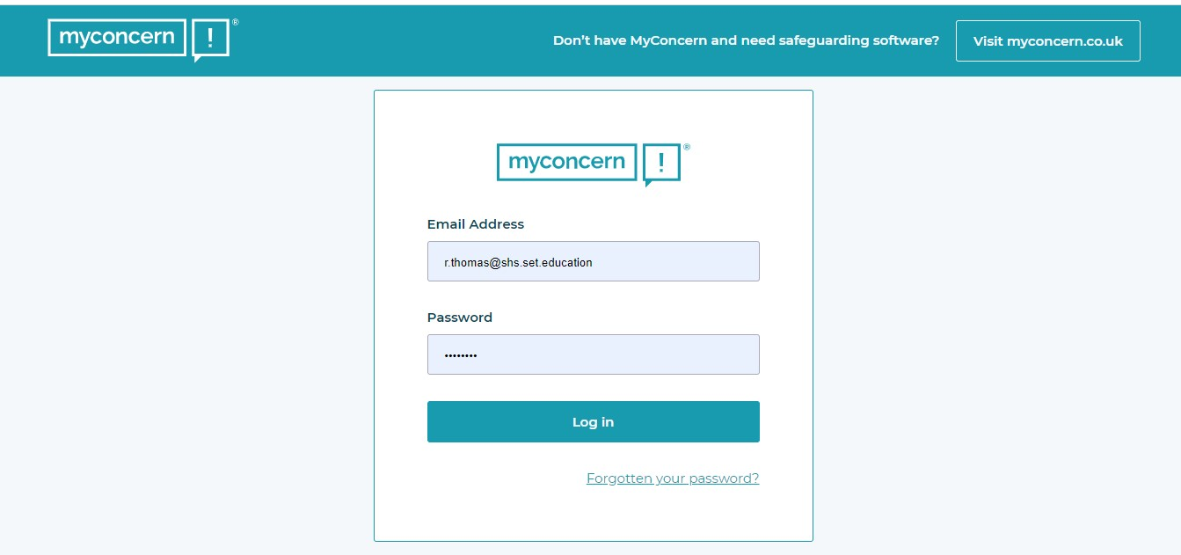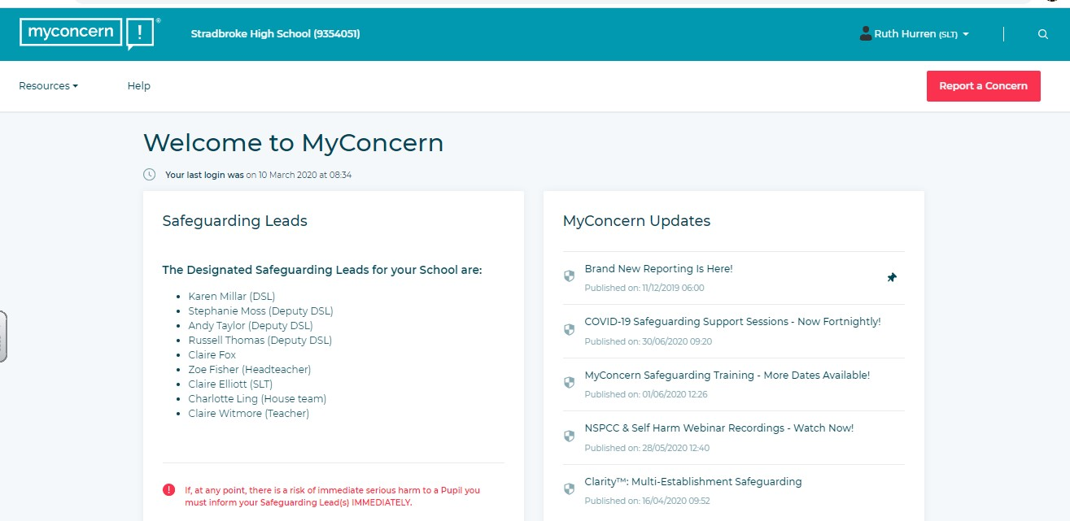

Insert your
school email
address
and the
password

you have set
up for your
self.

Click on
report a concern

if you
have an i
ssue to share.

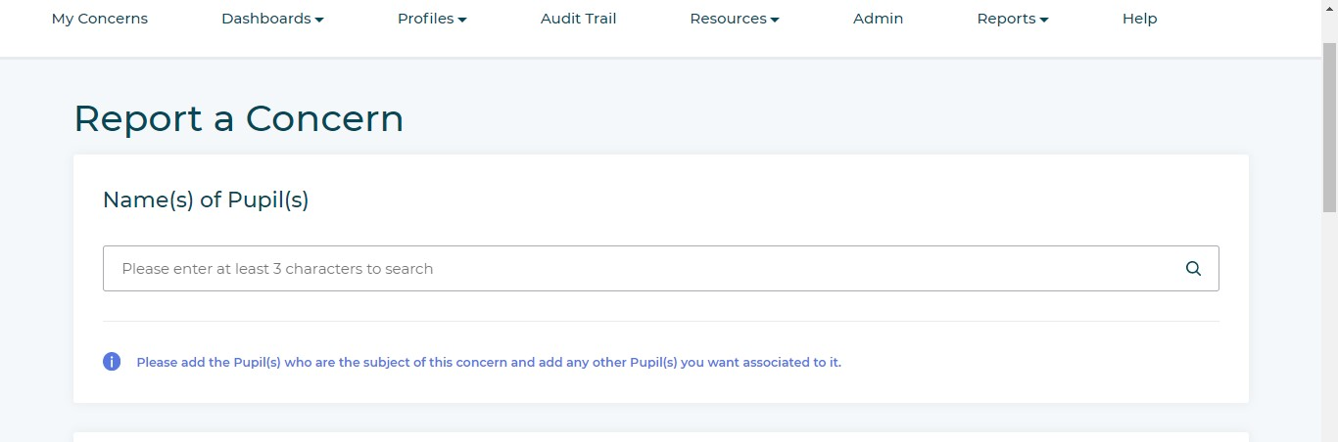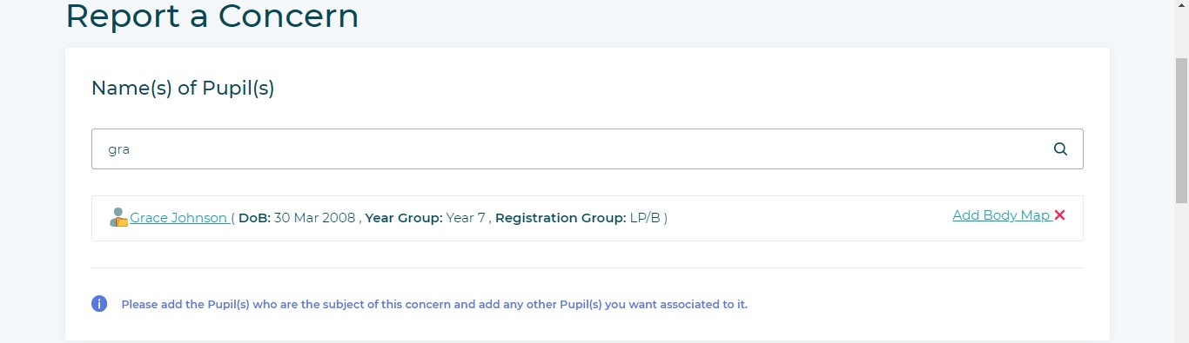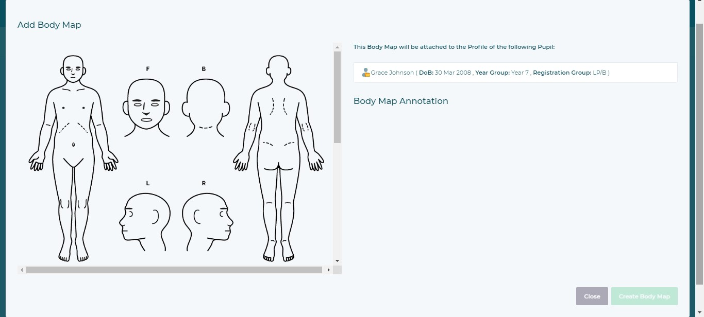

Start with ad
of
ding the name
ed
the student you are concern
hey
about. As you start typing, t
system will se
arch
f
s
or pupil
matching that name.

If it is appropriate to the conc
ern,
click ‘
ad
d body map’ now and
mark
rks
the location of any injuries/ma

Click to make a ma
rk on the body
map at the appropriate place then
add a note as to what was seen.
When you are
done
c
lick ‘Create
Body Map’

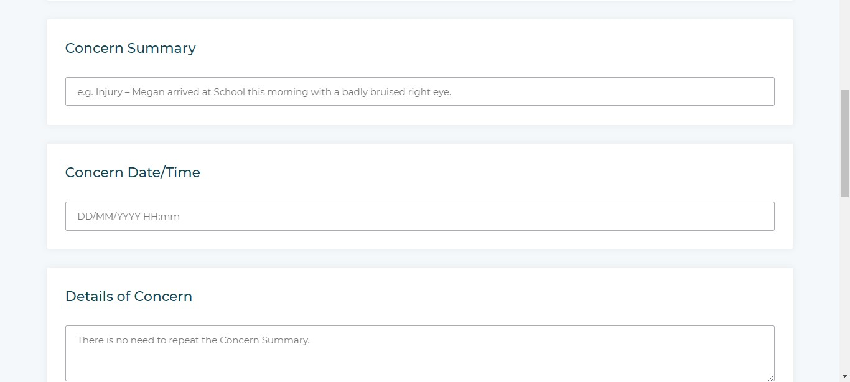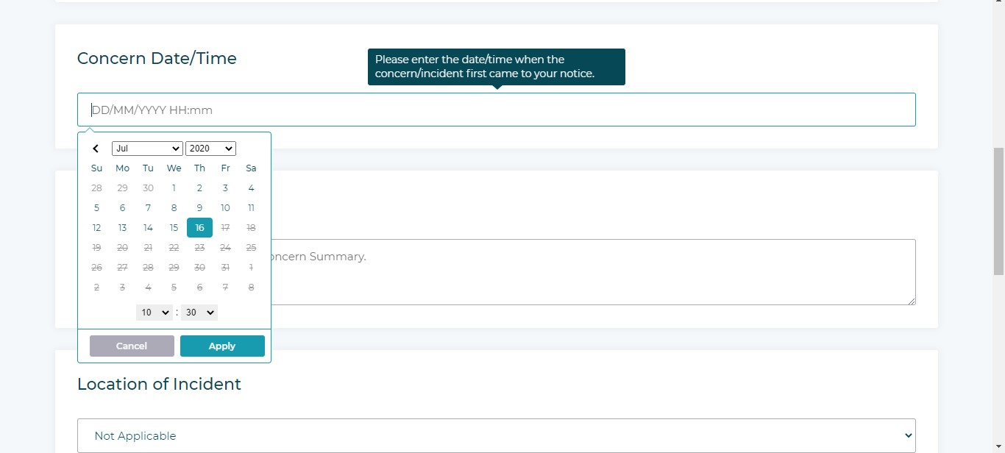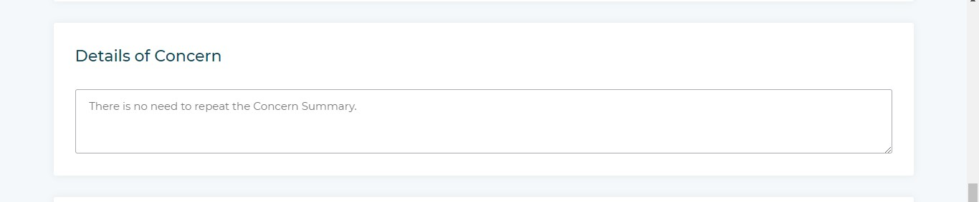

Then Write a short summary
of
your concern i.e.
“K
a
aren has
bruise on her face”

Add detail about your concern i.e
.
“
Lu
c
y

has a bruise on her left
cheek. She says she fell off her
bunk beds and hit

it on her desk at
the weekend. I am not sure this is
accurate as she has talke
d
previ
ously about having a lovely
big double bed””

Add the date and time that the

concern was brou
ght to your
attention
NOT

when you are
completin
g the form.

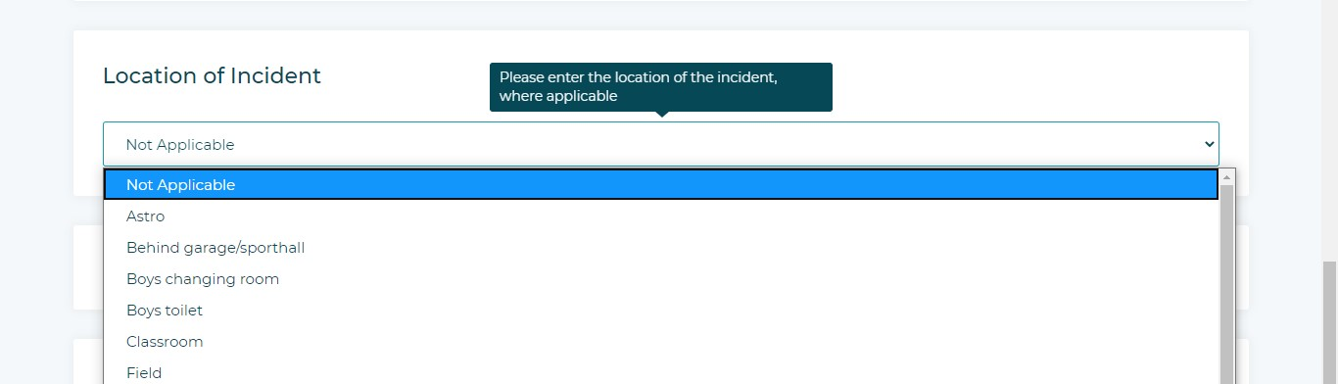

Add the location where to
concern
occurre
d. Pl
e
ase select on
e from the
drop
-
down.

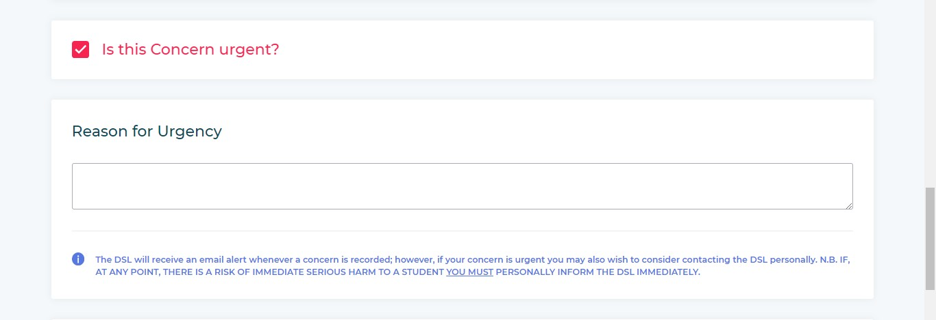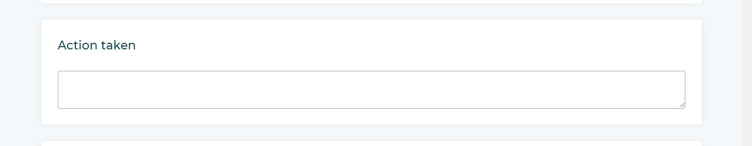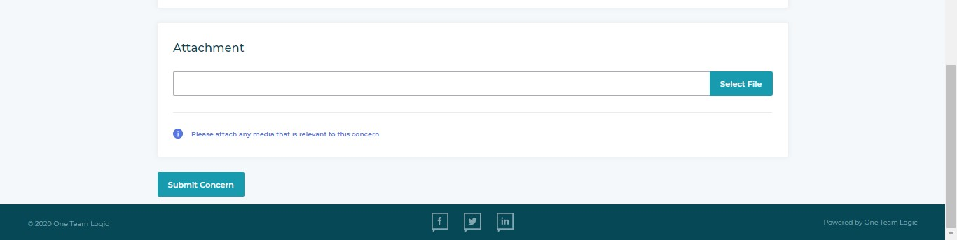

his
If this is critical concern tick t
box

an
d explain why i.e.
“Kar
_{en}
in the
talked about her mum’s anger
past and I am
en she
worried that wh
be in
goes home tonight she could
danger”

Record
any action that you ha
ve
taken. If this was a self
-
harm
concern, you could write
“I h
ave
taken

Karen

to first aid that h
ave
cleaned and dressed her woun
ds; she
does not need to visit the hos
pital.”

Attach any documents by browsing
on your computer or phone. This
could be a photograph or copy
of an
email.

If the child is at risk of se
rious

harm, you must mark
the concern a
s
urgent. You will then be asked to
provide
a reason for the urgency
and prompted to also inform a DS
L
in person.

Once you have checked you are
happy with a
ll the information you
have entered, hit
SUBMIT
CONCERN.

The system then automatically notifies the DSL and Deputy DSL’s via email that a concern has been logged. We can all log in and see what has happened whether we are in school or not, we can then allocate actions to each other or decide to take action

ourselves.
We will update the concern and the system automatically creates a chronology and log
(ALSO SEE ONLINE SYSfor us. This way we can all see what is happening with a student, even if we have not TEMS USED BY SCHOOLS MYCONCERN) managed to meet face to face.

18. Appendix C

BODYMAP
(This must be completed at time of observation)



Name of pupil: Date and time of
observation:
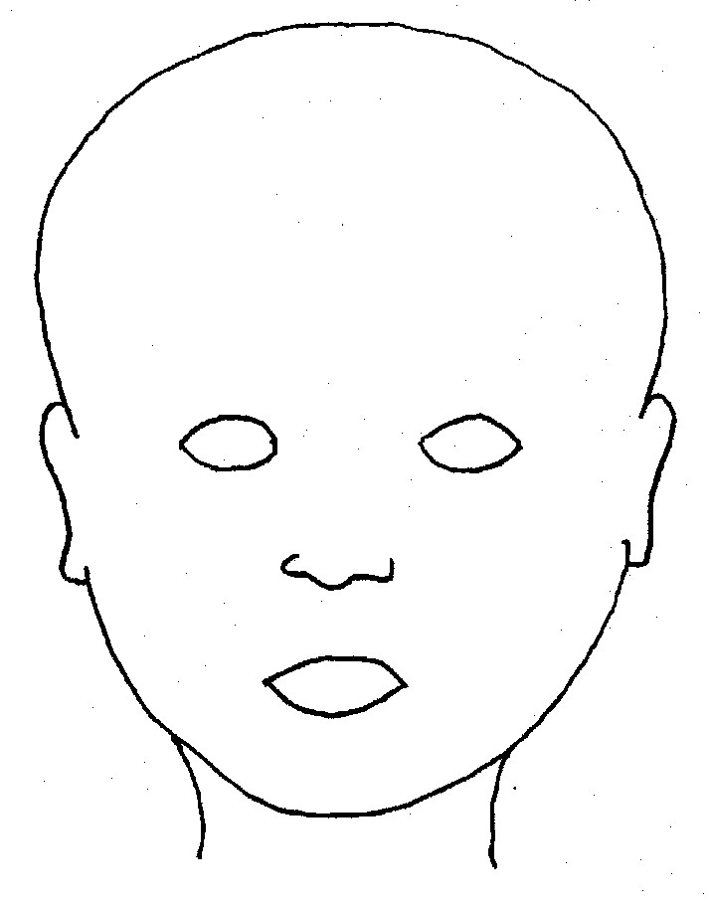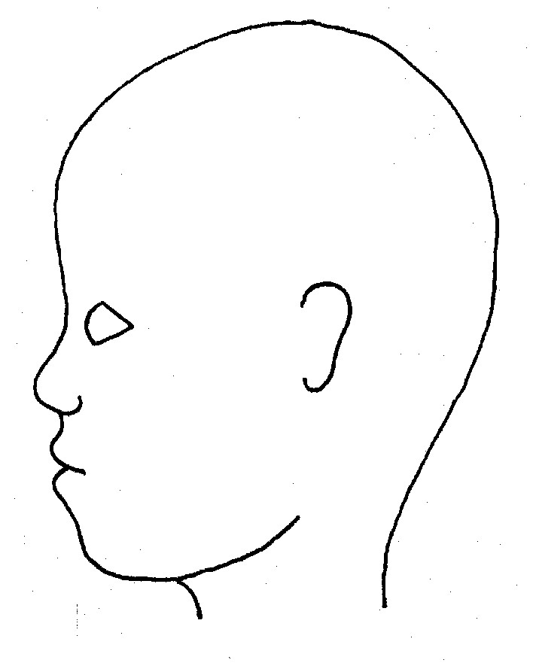

FRO
NT

BACK

RIG
HT

LEFT

Name of pupil: Date and time of
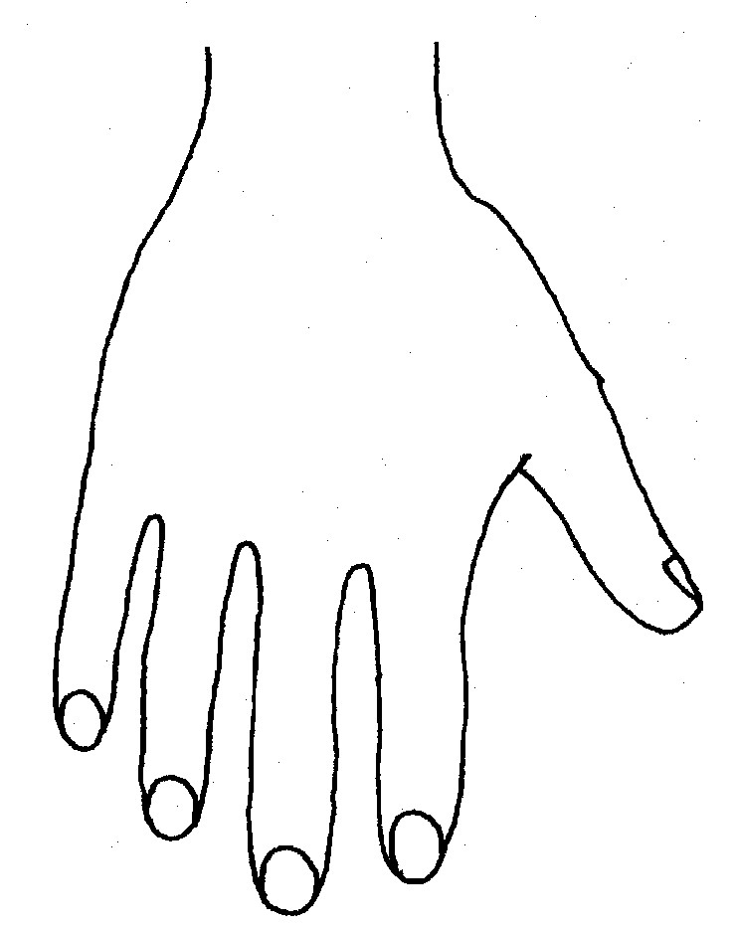
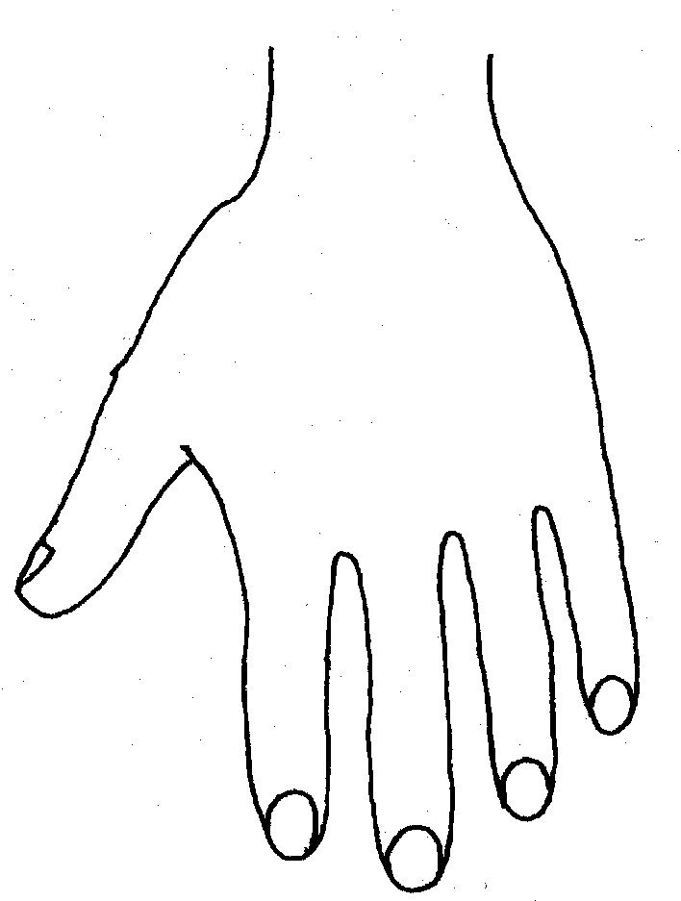


observation:

R

L

BACK

Name of Pupil: |  | Date and time of observation:


R

TOP

L

R

B
OT
TOM

L

 R L

INNER


R L
OUTER

Appendix D

Preventing Radicalisation and Extremism

Rationale

Children are vulnerable to extremist ideology and radicalisation. In today’s modern world, children may be exposed to many radical and extremist views, both through the people they may meet and through a wide range of media. There is no single way of identifying whether a child is likely to be susceptible to an extremist ideology. Background factors combined with specific influences such as family and friends may contribute to a child’s vulnerability. As with other safeguarding risks, staff should be alert to changes in children’s behaviour which could indicate that they may be in need of help or protection. Staff should use their judgement in identifying children who may be at risk of radicalisation and act proportionately which may include the DSL (or deputy) making a referral to the Channel programme.

Similar to protecting children from other forms of harm and abuse, protecting children from this risk is part of All Saints Schools Trust’s safeguarding approach.

Extremism is the vocal or active opposition to our fundamental values, including the rule of law, individual liberty and the mutual respect and tolerance of different faiths and beliefs. This also includes calling for the death of members of the armed forces. Radicalisation refers to the process by which a person comes to support terrorism and extremist ideologies associated with terrorist groups.
Terrorist is an action that endangers or causes serious violence to a person/people; causes serious damage to property; or seriously interferes or disrupts an electronic system. The use or threat must be designed to influence the government or to intimidate the public and is make for the purpose of advancing a political, religious or ideological cause. (Definitions are from current Government policy).

The PREVENT Duty and Channel

All schools and colleges are subject to a duty under section 26 of the CounterTerrorism and Security Act 2015 (the CTSA 2015), in the exercise of their functions, to have “due regard to the need to prevent people from being drawn into terrorism”. This duty is known as the Prevent duty.

The Prevent duty is seen as part of our school’s wider safeguarding obligations. The
Designated safeguarding lead and deputies should familiarise themselves with the
Revised Prevent duty guidance: for England and Wales, especially paragraphs 5776 which are specifically concerns with schools (and also covers childcare). The guidance is set out in terms of four general themes: Risk assessment, working in partnership, staff training, and IT policies.

Additional Support

Channel

Channel is a voluntary, confidential support programme which focuses on providing support at an early stage to people who are identified as being vulnerable to being drawn into terrorism. It provides a mechanism for schools to make referrals if they are concerned that an individual might be vulnerable to radicalisation. An individual’s engagement with the programme is entirely voluntary at all stages. Guidance on Channel is available at: Channel Guidance, and a Channel awareness e-learning programme is available for staff at: Channel General Awareness.

The school’s Designated Safeguarding Lead (and deputies) should be aware of local procedures for making a Channel referral. As a Channel partner, the school may be asked to attend a Channel panel to discuss the individual referred to determine whether they are vulnerable to being drawn into terrorism and consider the appropriate support required.

In School Approach

Children at All Saints Schools Trust are privy to a host of avenues where radicalisation and extremism is discussed:

Students are also taught about having their own voice and not always heeding the views of other people, especially if they have doubts about them.

The PSHE & RE curriculum covers aspects of bullying and rights.

The school has an internal referral process whereby staff can flag up any concerns they have around radicalisation and extremism. Any colleague with concerns should complete a Concern Form available in the staffroom and pass immediately to the Head of School/DSL. The DSL may then make a VTR (Vulnerable to Radicalisation) referral; at this stage parents should not be informed.

The concern is logged, and a timeline started. The Police and Social Services will be contacted. The school has a risk assessment in place and identifies students who may be at risk of Radicalisation and Extremism.

Radicalisation and Extremism Concern Form

Student name: | Staff logging concerns: | Date:
Nature of concern: |  | Tick:
Inappropriate content on phone

Inappropriate material held by student

Propaganda material

Overheard conversation

Gang mentality

Other concern

Describe in as much detail as possible your concern and note any behaviours observed:

Please continue over if necessary

Once completed hand this form IMMEDIATELY to a DSL

Radicalisation and Extremism Risk Assessment

The School
Question |  | Answer |  | Evidence/comment
Does the school have a policy |  | Yes |  | Part of Safeguarding policy
Does the school work with outside agencies on R and E |  | yes |  | Police and Social Care
Has the school got a nominated R and E Lead |  | yes |  | Melanie Barrow (CEO)
Do staff have a process to voice their concerns |  | yes |  | Internal Referral Form
Do children have a process to voice their concerns |  | yes |  | Class teacher, Headteachers/ Head of School
Are there opportunities for students to learn about R and E |  | yes |  | PSHE lessons and assemblies
Are there documented cases of R and E at the school |  | yes |  | Cohort of students are white British majority and Primary aged, no issues have ever been raised yet.
Is the school particularly prone to R and E |  | no
The schools conduct an annual Remembrance Service with the local British Legion Office held in school. All students participate in the service and pay their respects as an entire cohort. We also celebrate British Values.
Evaluation: | LOW RISK |  | Policy needs to be reviewed by Governing  Body every new academic year. Assemblies and curriculum are sufficient to provide students’ knowledge of R and E and what to look for to protect themselves and others at Primary School age.

The Students
Question |  | Answer | Evidence/comment
Are students aware of what R and E is |  | Yes- age appropriately | Assemblies, RE lessons and through PSHE
Are individual students risk assessed |  | yes | If a R &E concern form is filled in.  Students who are perceived to be vulnerable are identified early and flagged up to all staff.
Students at risk |  | none | Always monitoring situation
Evaluation: | LOW RISK |  | Staff will continue to monitor all students.

The community
The local community which the school serves consists predominantly of white British families.

Evaluation: | LOW RISK | As and when a concern is raised or an issue appears likely the school will work with families and the wider community on R & E.

PREVENT SELF ASSESSMENT

PREVENT OBJECTIVE 1: Clear leadership and accountable structures are in place and visible throughout the organisation
Evidence: | Tick:
There is an identified strategic PREVENT lead within the Trust | - Melanie Barrow and DSLs
The strategic lead understands the expectations and key priorities to deliver PREVENT and that this is embedded within Safeguarding Procedures | - Yes through Prevent training
The Senior Leadership Team are aware of the PREVENT Strategy and its objectives | - Yes through Prevent training
There is a clear awareness of roles and responsibilities throughout organisation regarding PREVENT | - Staff understand the need to flag up concerns and there is a clear process to follow
PREVENT safeguarding responsibilities are explicit within the Schools Safeguarding Team | - R and E is connected to Safeguarding and Child Protection Policy and systems in school
The Prevent agenda and its objectives has been embedded within the appropriate Safeguarding processes | - Part of annual Safeguarding training

PREVENT OBJECTIVE 2: Staff and the Governing Body have been appropriately trained according to their role
Evidence: | Tick:
Further training on the Prevent agenda is made available to the Strategic Prevent lead and Safeguarding leads where appropriate | - All Staff and Govs complete online  - Channel Training
There is appropriate staff guidance and literature available to staff on the Prevent agenda | - There isappropriate staff guidance and literature available to staff on the Prevent agenda

PREVENT OBJECTIVE 3: An appropriate reporting and referral process is in place and referrals are being managed effectively
Evidence: | Tick:
Ensure that preventing young people from being exposed to radicalisation or extremism is part of the school’s safeguarding policies and procedures. | - Also in safeguarding policy and part of staff induction
A single point of contact [SPoC] for any PREVENT concerns raised by staff within the school has been identified | - Melanie Barrow
An appropriate internal PREVENT referral process has been developed | - Referral form  and clear process
Partner agency communication channels have been developed | - PREVENT Lead at Suffolk Police (Andy Hill, Sgt 3482) first port of call when outside agencies need to be consulted or for making a Channel referral.
An audit trail for notification reports/referrals exists | - Time line of event created once referral is made
PREVENT referrals/notifications are being managed or overseen by relevant staff | - Contact Melanie Barrow CEO to oversee
A process is in place to identify and develop ‘lessons learnt’ | - School would consult with county safeguarding lead and Sgt Andy Hill

PREVENT OBJECTIVE 4: A broad and balanced curriculum that helps protect students against extremism and promotes community cohesion
Evidence: | Tick:
School has a range of initiatives and activities that promote the spiritual, moral, social and emotional needs of children aimed at protecting them from radicalisation and extremist influences | - PSHE, assemblies and Ethics curriculum
The school delivers training that helps develop critical thinking skills around the power of influence, particularly on-line and through social media. | - PSHE  lessons, RE lessons, assemblies etc
Students are aware of the benefits of community cohesion and the damaging effects of extremism on community relations. | - Through PSHE, RE and assemblies
Staff are able to provide appropriate challenge to students, parents or governors if opinions are expressed that are contrary to  fundamental British values and promotion of community cohesion. | - referral system in place that follows safeguarding processes

Preventing radicalisation
Children are vulnerable to extremist ideology and radicalisation. Similar to protecting children from other forms of harm and abuse, protecting children from this risk should be a part of a school’s or college’s safeguarding approach.

Extremism²⁰ is the vocal or active opposition to our fundamental values, including the rule of law, individual liberty and the mutual respect and tolerance of different faiths and beliefs. This also includes calling for the death of members of the armed forces.

Radicalisation²¹ refers to the process by which a person comes to support terrorism and extremist ideologies associated with terrorist groups.

There is no single way of identifying whether a child is likely to be susceptible to an extremist ideology. Background factors combined with specific influences such as family and friends may contribute to a child’s vulnerability. Similarly, radicalisation can occur through many different methods (such as social media) and settings (such as the internet).

However, it is possible to protect vulnerable people from ideology and intervene to prevent those at risk of radicalisation being radicalised. As with other safeguarding risks, staff should be alert to changes in children’s behaviour which could indicate that they may be in need of help or protection. Staff should use their judgement in identifying children who may be at risk of radicalisation and act proportionately which may include the designated safeguarding lead (or deputy) making a referral to the Channel programme.

The Prevent duty
All schools and colleges are subject to a duty under section 26 of the Counter-Terrorism and Security Act 2015 (the CTSA 2015), in the exercise of their functions, to have “due regard²² to the need to prevent people from being drawn into terrorism”.²³This duty is known as the Prevent duty.

The Prevent duty should be seen as part of schools’ and colleges’ wider safeguarding obligations.
Designated safeguarding leads and other senior leaders should familiarise themselves with the Revised Prevent duty guidance: for England and Wales, especially paragraphs 57-76 which are specifically concerns with schools (and also covers childcare). The guidance is set out in terms of four general themes: Risk assessment, working in partnership, staff training, and IT policies.

Additional support

- As defined in the Government’s Counter Extremism Strategy
- As defined in the Revised Prevent Duty Guidance for England and Wales
- According to the Prevent duty guidance ‘having due regard’ means that the authorities should place an appropriate amount of weight on the need to prevent people being drawn into terrorism when they consider all the other factors relevant to how they carry out their usual functions.
⁴“Terrorism” for these purposes has the same meaning as for the Terrorism Act 2000 (section 1(1) to (4) of that Act).
The department has published advice for schools on the Prevent duty. The advice is intended to complement the Prevent guidance and signposts other sources of advice and support.

There is additional guidance: Prevent duty guidance: for further education institutions in England and Wales that applies to colleges.

Educate Against Hate, a website launched by Her Majesty’s Government has been developed to support and equip school and college leaders, teachers, and parents with information, tools and resources (including on the promotion of fundamental British values) to help recognise and address extremism and radicalisation in young people. The platform provides information on and access to training resources for teachers, staff and school and college leaders, some of which are free such as Prevent e-learning, via the Prevent Training catalogue.

Channel
Channel is a programme which focuses on providing support at an early stage to people who are identified as being vulnerable to being drawn into terrorism. It provides a mechanism for schools to make referrals if they are concerned that an individual might be vulnerable to radicalisation. An individual’s engagement with the programme is entirely voluntary at all stages. Guidance on Channel is available at: Channel Guidance, and a Channel awareness e-learning programme is available for staff at: Channel General Awareness.

The school or college’s Designated Safeguarding Lead (and any deputies) should be aware of local procedures for making a Channel referral. As a Channel partner, the school or college may be asked to attend a Channel panel to discuss the individual referred to determine whether they are vulnerable to being drawn into terrorism and consider the appropriate support required.

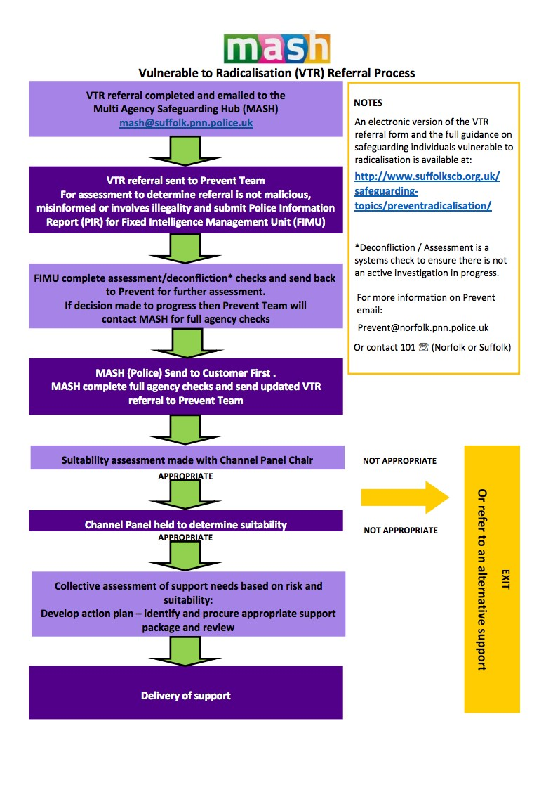

Appendix E

 Low-Level Concerns Policy

This section is based on concerns that do not meet the harm threshold in part 4 of Keeping Children Safe in Education.

This applies to all concerns (including allegations) about members of staff, including supply teachers, volunteers and contractors, which do not meet the harm threshold.

Concerns may arise through, for example:
Suspicion
Complaint
Disclosure made by a child, parent or other adult within or outside the school Pre-employment vetting checks
We recognise the importance of responding to and dealing with any concerns in a timely manner to safeguard the welfare of children.

Definition of Low-Level Concerns
The term ‘Low-Level’ concern is any concern – no matter how small – that an adult working in or on behalf of the school may have acted in a way that:

Is inconsistent with the staff code of conduct, including inappropriate conduct outside of work, and
Does not meet the allegations threshold or is otherwise not considered serious enough to consider a referral to the designated officer at the local authority.

Examples of such behaviour could include, but are not limited to:

Being overly friendly with children
Having favourites
Taking photographs of children on their mobile phone
Engaging with a child on a one-to-one basis in a secluded area or behind a closed door Using inappropriate sexualised, intimidating or offensive language

Sharing Low-Level concerns
We recognise the importance of creating a culture of openness, trust and transparency to encourage all staff to share low-level concerns so that they can be addressed appropriately.

We will create this culture by:
Ensuring staff are clear about what appropriate behaviour is, and are confident in distinguishing expected and appropriate behaviour from concerning, problematic or inappropriate behaviour, in themselves and others
Have clear policies and procedures
Empowering staff to share any low-level concerns
Empowering staff to self-refer
Addressing unprofessional behaviour and supporting the individual to correct it at an early stage
Providing a responsive, sensitive and proportionate handling of such concerns when they are raised
Helping to identify any weakness in the school’s safeguarding system

Reporting a low level concern
- Low level concerns about a member of staff should be reported to the Headteacher as per the school’s Child Protection procedures.
- If the concern is about the Headteacher this should be reported to the Chair of Governors.
- Low level concerns about supply staff, contractors and local authority visiting staff will also be reported to their employers.

Staff should use the school’s Low-Level Concerns Reporting Form (below).

Responding to low-level concerns
If the concern is raised via a third party, the headteacher will collect evidence where necessary by speaking:
Directly to the person who raised the concern, unless it has been raised anonymously
To the individual involved and any witnesses

The headteacher will use the information collected to categorise the type of behaviour and determine any further action, in line with the school’s staff Code of Conduct.
- Allegations that meet the harm threshold will be referred to the LADO for advice.
- Low level concerns that the school feel may need further guidance on will be referred to the LADO for advice.
- Low level concerns that the school feel they can deal with internally will be dealt with via the school’s usual child protection investigation process.
- The school will engage with its HR provider where it is necessary to undertake further investigation and/or deal with the concern under relevant processes.

Record keeping
All low-level concerns will be recorded in writing (form below).

In addition to details of the concern raised, records will include the context in which the concern arose, any action taken and the rationale for decisions and action taken.
Records will be:
Kept confidential, held securely and comply with the DPA 2018 and UK GDPR
Reviewed so that potential patterns of concerning, problematic or inappropriate behaviour can be identified. Where a pattern of such behaviour is identified, we will decide on a course of action, either through our disciplinary procedures or, where a pattern of behaviour moves from a concern to meeting the harms threshold as described in section 1 of this appendix, we will refer it to the designated officer at the local authority Retained at least until the individual leaves employment at the school

Where a low-level concern relates to a supply teacher or contractor, we will notify the individual’s employer, so any potential patterns of inappropriate behaviour can be identified.

Reviewing a low-level concern
Records will be reviewed so that potential patterns of concerning, problematic or inappropriate behaviour can be identified.
Where a pattern of such behaviour is identified, the Headteacher will decide on a course of action, which may include:
- Disciplinary investigation and/or proceedings
- Management Advice, including recommendations for training
- Referral to the LADO (where a pattern of behaviour moves from a concern to meeting the harm threshold).

If the concern relates volunteers, or any other concerns arise, school can contact the LADO for further advice.

References

We will not include low-level concerns in references unless:
The concern (or group of concerns) has met the threshold for referral to the designated officer at the local authority and is found to be substantiated; and/or
The concern (or group of concerns) relates to issues which would ordinarily be included in a reference, such as misconduct or poor performance.

Low-Level Concern Form
Please use this form to share any concern – no matter how small, and even if no more than causing a sense of unease or a ‘nagging doubt’ – that an adult may have acted in a way that:
- is inconsistent with ASST staff code of conduct, including inappropriate conduct outside of work, and
- does not meet the allegation threshold, or is otherwise not serious enough to consider a referral to the LADO.
You should provide a concise record – including brief context in which the low-level concern arose, and details which are chronological, and as precise and accurate as possible – of any such concern and relevant incident(s) (and please use a separate sheet if necessary).

The record should be signed, timed and dated and returned to the Headteacher.
Details of Concern

Name of Staff member:
Role:

Name: Date/ Time:

Position: Signed:

Self-Disclosure Register
Member of  Staff | Parent / Pupil | Type of contact | Date | Action if required

The Trust Low-Level Concerns policy is included within this policy (see appendix)
Annex A of KCSiE is a condensed version of Part One of KCSiE. Whilst it is a matter for schools, based on their assessment, SCC and Suffolk Safeguarding Partnership take the view that it should only be those staff that do not work directly with children in school, e.g. cleaners who come in out of school hours, who are expected to only read the condensed version of Part One of KCSiE.
The governing body/proprietor may decide that for some roles should read additional parts of the guidance e.g. colleagues involved in safer recruitment administration including the maintenance of the single central record and Designated Safeguarding Lead/Safeguarding Governor should also read Part Three of KCSiE.
Section 175, Education Act 2002 – for management committees of pupil referral units, this is by virtue of regulation 3 and paragraph 19A of Schedule 1 to the Education (Pupil Referral Units) (Application of Enactments) (England) Regulations 2007
Set out in paragraphs 81-91 of KCSiE
See LA explanatory note on the requirements around children having an appropriate adult Schools-StopSearch-v2.3.pdf (squarespace.com)
Whilst it is a matter for schools, based on their assessment, SCC and Suffolk Safeguarding Partnership take the view that it should only be those staff that do not have regular contact with children in school, e.g. cleaners who come in out of school hours, who are expected to only read the condensed version of Part One of KCSiE.
Dependent on school stance on the condensed version of KCSiE. Whilst it is a matter for schools, based on their assessment, SCC and Suffolk Safeguarding Partnership take the view that it should only be those staff that do not have regular contact with children in school, e.g. cleaners who come in out of school hours, who are expected to only read the condensed version of Part One of KCSiE.
UKCIS guidance: Sharing nudes and semi-nudes advice for education settings.
Under section 5B(11) (a) of the Female Genital Mutilation Act 2003, ‘teacher’ means, in relation to England, a person within section 141A(1) of the Education Act 2002 (persons employed or engaged to carry out teaching work at schools and other institutions in England)
N.B. The exception to this process will be in those cases of known FGM where there is a mandatory requirement for the teacher to report directly to the police, although the DSL should also be made aware.
As defined in the Government’s Counter Extremism Strategy
As defined in the Revised Prevent Duty Guidance for England and Wales
As defined in the Terrorism Act 2000 (TACT 2000)
According to the Prevent duty guidance ‘having due regard’ means that the authorities should place an appropriate amount of weight on the need to prevent people being drawn into terrorism when they consider all the other factors relevant to how they carry out their usual functions.
“Terrorism” for these purposes has the same meaning as for the Terrorism Act 2000 (section 1(1) to (4) of that Act).
Under Section 5B(11)(a) of the Female Genital Mutilation Act 2003, “teacher” means, in relation to England, a person within section 141A(1) of the Education Act 2002 (persons employed or engaged to carry out teaching work at schools and other institutions in England).
Section 5B(6) of the Female Genital Mutilation Act 2003 states teachers need not report a case to the police if they have reason to believe that another teacher has already reported the case.

